

**USER MANUAL SIGN-OFF**

**Authorization Memorandum**

This form is to sign-off completion of the Design Phase for **CAMPUS MANAGEMENT SOFTWARE AT WORLD SKILL CENTER (WSC).**

World Skill Centre (WSC) acknowledges receipt of the deliverables as part of the Design Phase through the submission of this document.

|  |  |
| --- | --- |
| **MODULE NAME** | **Training And Placement** |
| **MODULE OWNER** | **Mr. Rajan Pradhan** |

**WSC AUTHORITY NAME AND SIGNATURE**

**SOUL AUTHORITY NAME AND SIGNATURE**

 



**Sustainable Outreach And Universal**

**Leadership (SOUL) Limited**

**User Manual**

Of

**Training & Placement**

For Implementation of

**Campus Management Software**

at

**World Skill Center (WSC)**

**Confidentiality**

This document is a strictly confidential communication to and solely for the use of the recipient and may not be reproduced or circulated without SOUL Ltd’s prior written consent. If you are not the intended recipient, you may not disclose or use the information in this documentation in any way

**Document Control History**

|  |  |  |  |  |
| --- | --- | --- | --- | --- |
| **Date** | **Version No.** | **Created By** | **Affected Sections** | **Reviewed By** |
| 09-10-2023 | 1.0 | Sayantan Ghosh |  |  |
| 02-01-2024 | 2.0 | Sayantan Ghosh |  |  |
|  |  |  |  |  |

Table Of Contents

1 Introduction 4

1.1 Background 4

1.2 Scope and Purpose of the document 5

2 General Procedures 5

2.1 General Procedures for a Save Screen 5

2.1.1 Create of New document 5

2.1.2 View a Saved Document 7

2.1.3 Delete a Saved Document 7

2.1.4 Rename a Saved Document 8

2.1.5 Print a Saved Document type 9

2.1.6 View the saved document in different format. 10

2.1.7 View the saved documents by applying filters. 11

2.2 General Procedure for a Submittable Screen 14

2.2.1 Create of New document 14

2.2.2 Cancel a Submitted Document 15

2.2.3 Amend a Submittable Document 16

2.2.4 Action Menu on a document. 17

3 Master 18

3.1 TnP Program 18

3.2 TnP Event 20

3.3 Placement Company 21

3.4 Participant Registration 23

3.5 Entrepreneurship 24

4 Training 26

4.1 Participant Attendance 26

4.2 Internship Drive 27

4.3 Internship Application 29

4.4 Internship Participant Selection 30

4.5 Internship Final List Declaration 32

4.6 Internship Completion Status 33

4.7 Event Feedback 35

5 Placement 36

5.1 Placement Drive 36

5.2 Placement Drive Application 38

5.3 Placement Blocked Student 40

5.4 Placement Tool 41

5.5 Selection Round 43

6 Training Certificate 44

6.1 Generate Certificate 44

6.2 Generate Certificate Tool 46

7 Security: User access and authorization 47

7.1 TnP Program 47

7.2 TnP Event 47

7.3 Participant Registration 48

7.4 Participant Attendance 48

7.5 Event Feedback 48

7.6 Generate Certificate Tool 48

7.7 Generate Certificate 48

7.8 Placement Company 49

7.9 Internship Drive 49

7.10 Internship Application 49

7.11 Internship Participant Selection 49

7.12 Internship Final List Declaration 49

7.13 Internship Completion Status 50

7.14 Placement Drive 50

7.15 Placement Drive Application 50

7.16 Placement Blocked Student 50

7.17 Placement Tool 50

7.18 Selection Round 51

7.19 Selection Round Report 51

7.20 Entrepreneurship 51

# Introduction

The World Skill Center (WSC) is a premier advanced skill training institute established by the Government of Odisha, Skill Development and Technical Education Department, through the Odisha Skill Development Authority (OSDA). The WSC will impart advanced skill training in eight trades from engineering and service sectors. WSC caters primarily to induct the best talent from ITIs and Polytechnics and training them to become globally employable in emerging areas such as "Industry 4.0". WSC is housed in a state-of-the-art, 18-storey, air-conditioned building with nearly half a million square feet of space in the heart of capital city of Bhubaneswar.

With the implementation of campus management software for WSC the goal is to streamline the operations and functions of the campus by integrating various processes, such as admissions, course registration, academic progress tracking, and financial management, HRMS, Procurement and Inventory management, etc into a unified system. The implementation also aims at providing a user-friendly interface for all stakeholders, making it easier for them to access the necessary information and complete their tasks with ease. The modules to be covered during the implementation of the software include:

|  |  |
| --- | --- |
| Students Management Modules | Infrastructure Management |
| Academic System | Finance and Accounting System |
| Procurement & Inventory Management | Training and Placement |
| Human Resources Management System | Application Integration |

# 

## Background

The Web Based Campus Management Application at World Skill Centre (WSC) application is required by WSC for the smooth operation of all departments / support functions with on-line delivery of services to all stakeholders.

The project aims to create a mechanism to provide the basis for evolution of an IT enabled state of the art workflow automation system in a planned manner.

## Scope and Purpose of the document

The design documents track the necessary information required to effectively define architecture and system design in order to give the development team guidance on the architecture of the system to be developed. Its intended audience is the project manager, project team, and development team. Some portions of this document, such as the user interface (UI), may be shared with the client/user, and other stakeholders whose input/approval into the UI is needed.

This document covers all the design aspects of Training module. This module helps in organizing the entire training setup such as Participants Database, Application forms, Participant attendance etc.

The scope of Training and Placement module

* **Seminars, Conferences and Internship organization and management**
* **Training program and event creation**
* **Participant selection**
* **Feedback recording**
* **Certificate generation**
* **Attendance recording**

# General Procedures

## General Procedures for a Save Screen

### Create of New document

Login in to the system

Go the required workspace

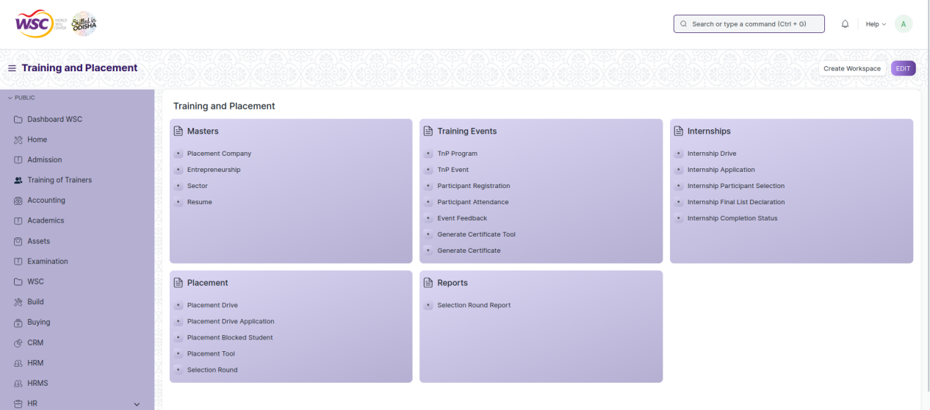

Go to the required screen.

Click on the ***“+Add Screen Name”*** button in the right corner of the screen.

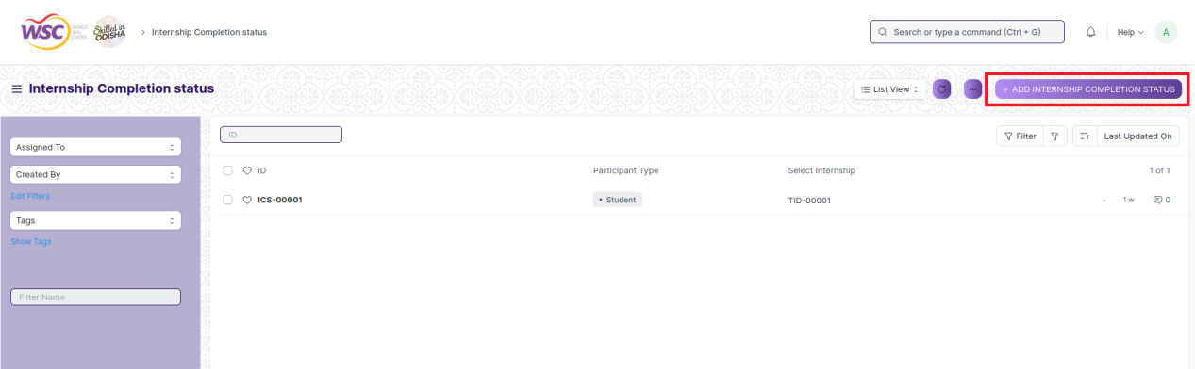

(Example : For addition in the new Placement Company , click +Add Placement Company button).

Enter the required data.

Click on “***Save”*.**

After saving , the record will be visible in the List View of the screen.

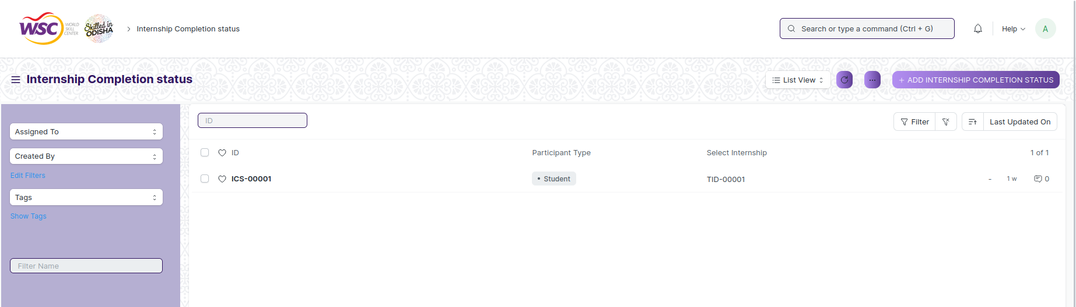

(Example : List view of saved Placement Company)

**Note :** The process of creation can only be carried out by employees who have necessary permission.Kindly refer to the Screen wise permission section in the document.

### View a Saved Document

Log in to the system.

Go to the required workspace

Go to the required screen.

Click on the required document from the list view of the screen.

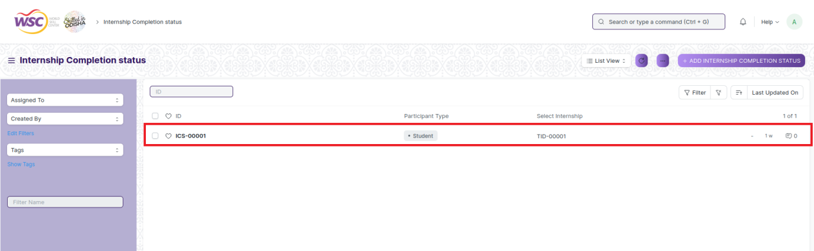

(Example : View of “ICS-00001” Document of Internship Completion Status Screen)

View the clicked document.

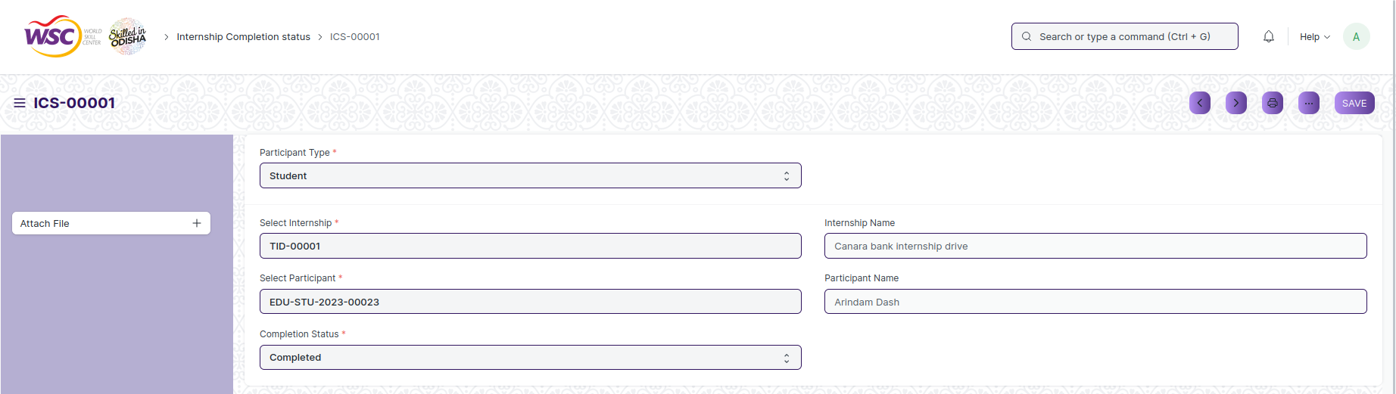

(Example : View of the “ICS-00001” in Internship Completion Status Screen)

**Note :** The process of view can only be carried out by employees who have necessary permission.Kindly refer to the Screen wise permission section in the document.

### Delete a Saved Document

Log in to the system

Go to the required workspace

Go to the required screen.

Click on the required document from the list view of the screen.

Click on the 3 dots in the right corner of the screen.

Click on *“****Delete”*.**

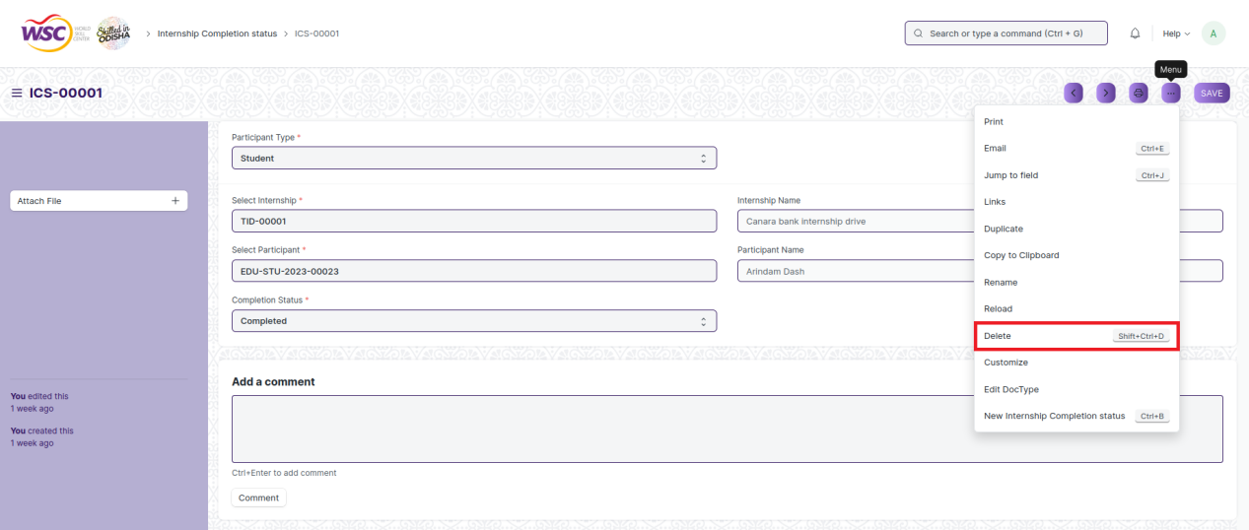

(Example : Deletion of “ICS-00001” document of Internship Completion Status)

Click yes if you want to delete the selected document.

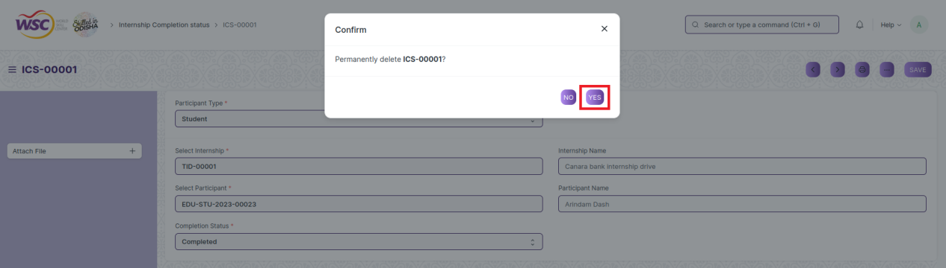

(Example : Clicking Yes to Delete permanently the document)

**Note :** The process of deletion can only be carried out by employees who have necessary permission.Kindly refer to the Screen wise permission section in the document.

### Rename a Saved Document

Login to the screen.

Go to the required workspace

Go to the required screen.

Click on the required document from the list view of the screen.

Click on the 3 dots in the right corner of the screen.

Click on *“****RENAME”*** .

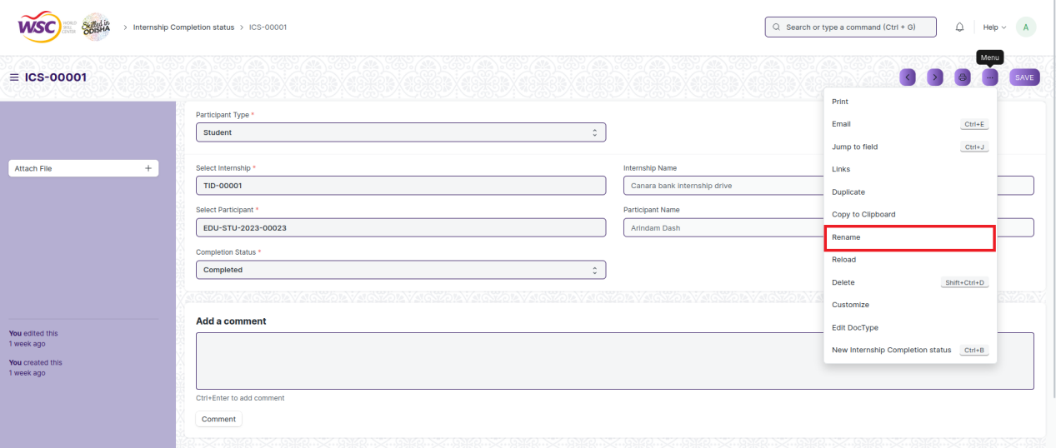

Click on *“****Rename”*** button to rename the document.

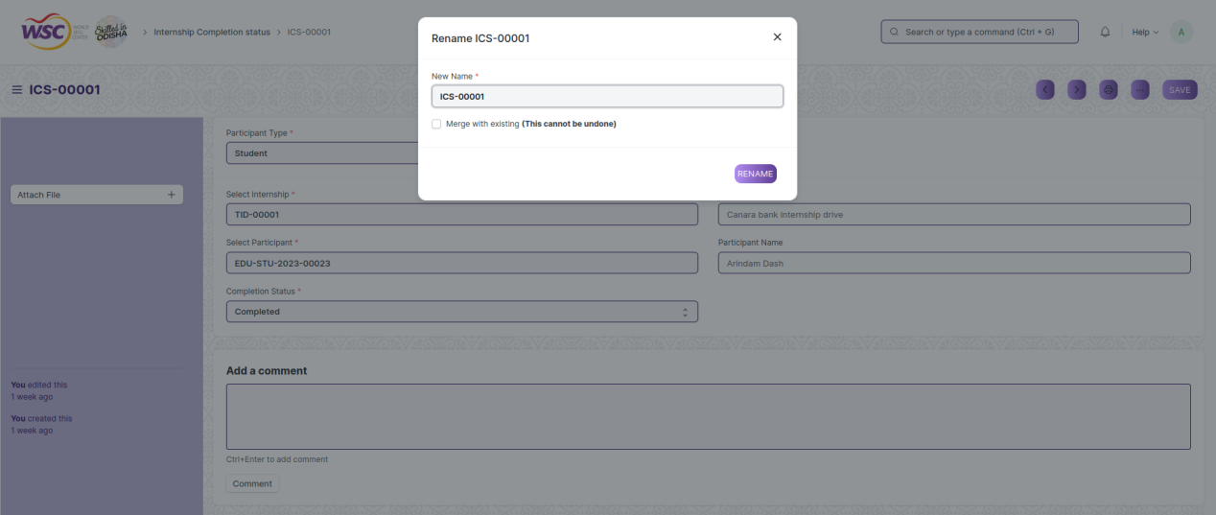

**Note :** The process of deletion can only be carried out by employees who have necessary permission.Kindly refer to the Screen wise permission section in the document.

### Print a Saved Document type

Login to the system

Go to the required workspace

Go to the required screen.

Click on a saved document in the screen.

Click on the print button present in the right corner of the screen.

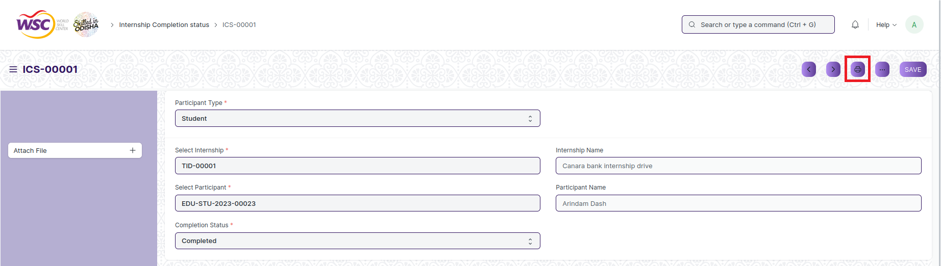

A new screen will open.

Click on the print button to Print the document.

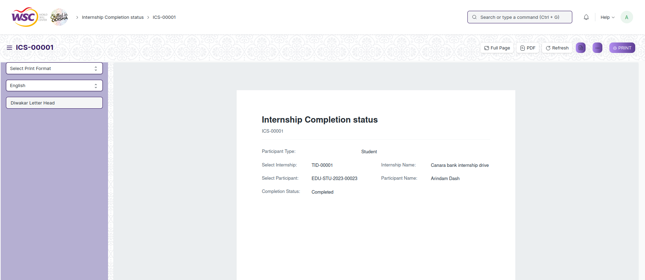

To download the employment type as PDF , click on the PDF button .

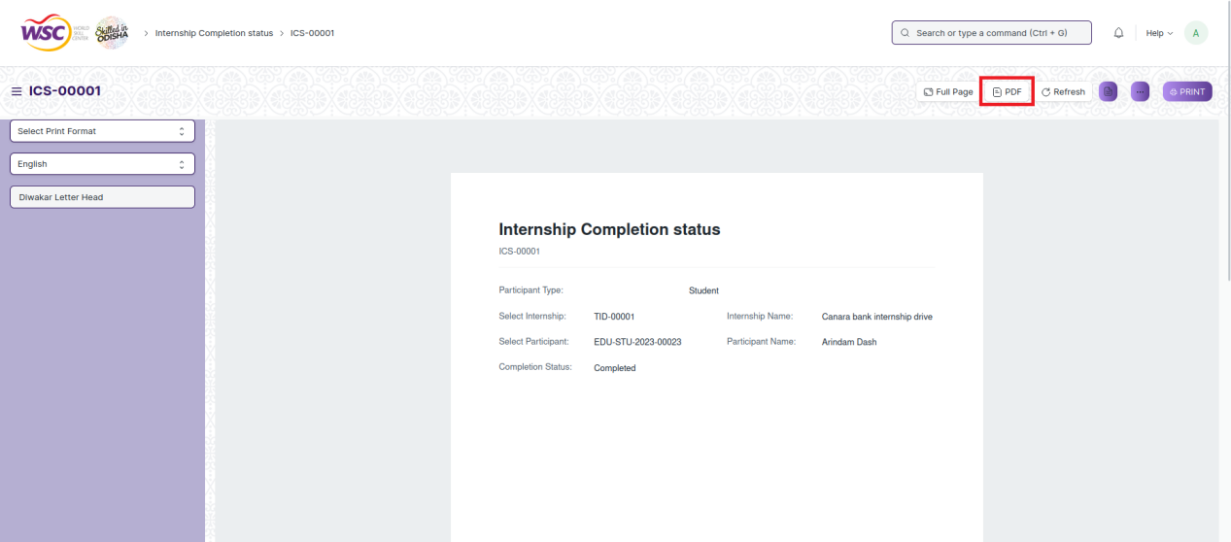

**Note :** The process of printing can only be carried out by employees who have the necessary permission.

### View the saved document in different format.

Login to the system

Go to the required workspace

Go to the required screen.

Click on the List View Button in the screen.

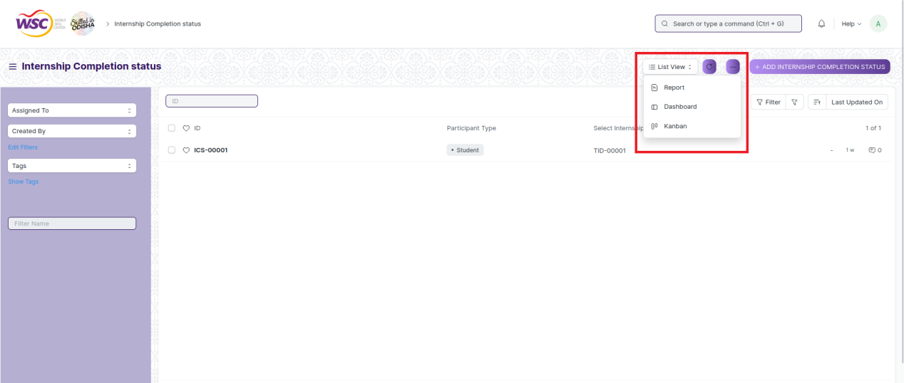

Select the appropriate view type that you want.

**Note :** The List view button can only be showed to the employees who have necessary permission.

### View the saved documents by applying filters.

Login to the screen.

Go to the required workspace.

Go to the required screen.

Click on the ***“Filter”***.

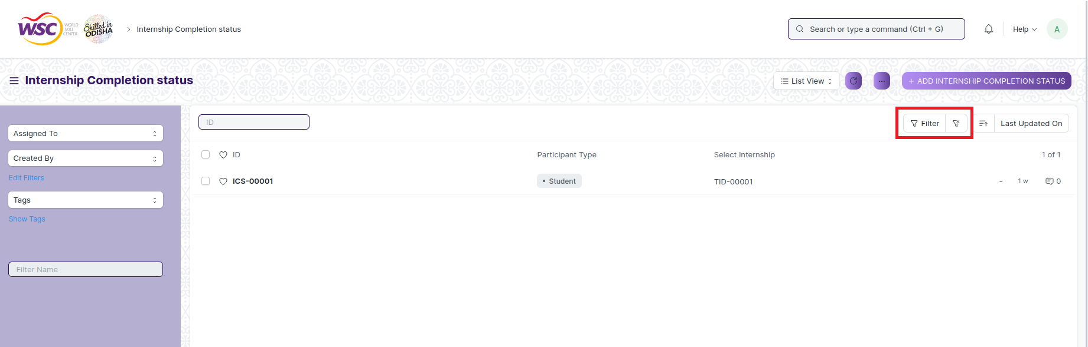

Select the field of the document based on which you wish to filter the records. All the fields in a form will be selectable in this list.

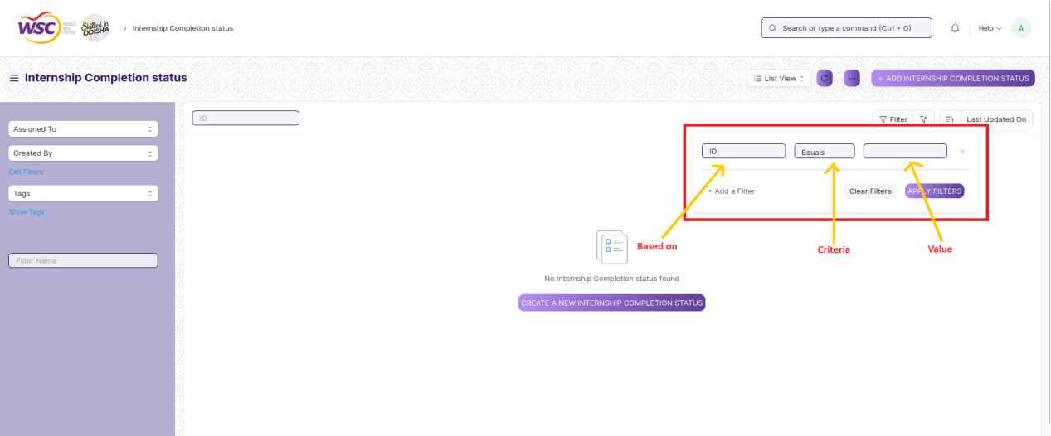

**Based On :** For the field, you will be required to put a value of the field. In the 'based on' field.

**Criteria :** You can define criteria based on which the system will search the document.The different conditions on which the filters are based are: Equals, Not Equal, Like, Not Like, In, Not In, =,>,< etc.

**Value :** Here, you will be required to enter the value for which you are running the document search.

**Some Examples of Viewing the documents in the list view after applying filters.**

Filter on Internship Completion Status screen where Participant Type Equals to Student. After clicking the Apply Filter button, all the filtered document will show in the screen.

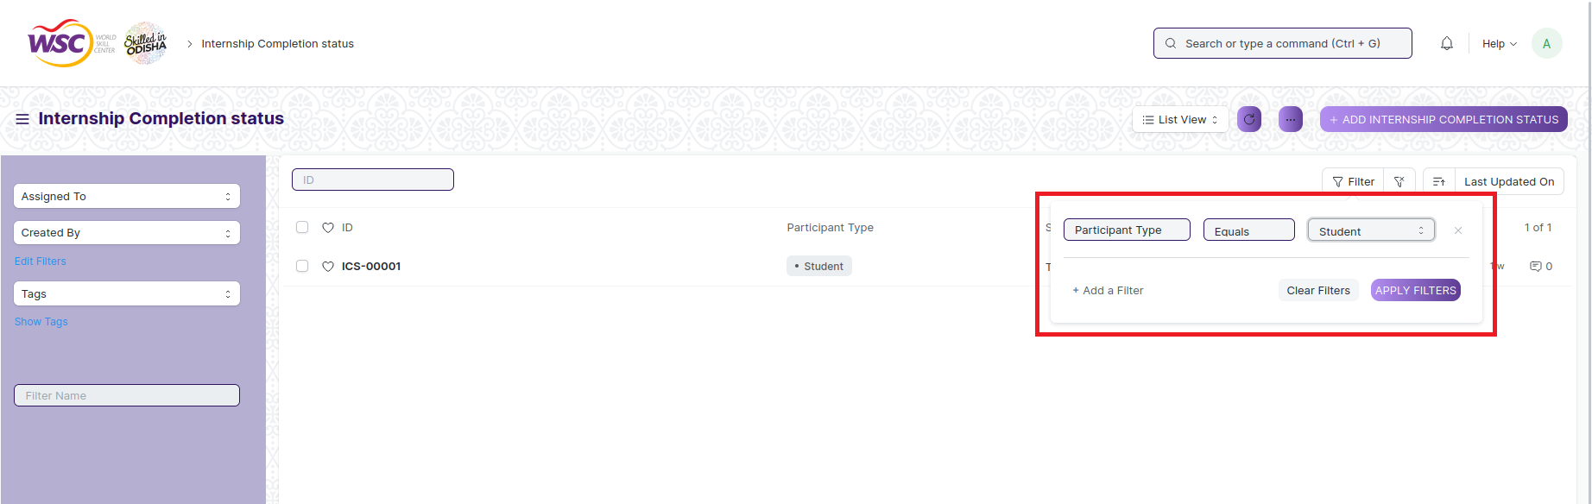

Filter on Internship Completion Status where, the Participant Type equals to ‘Student’.



Filter on Internship Completion Status screen , where completion status equals to completed.

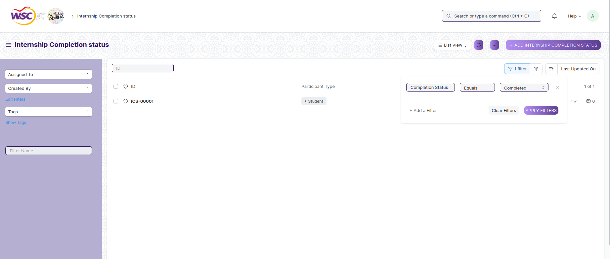

You can also apply multiple filters at a time. To remove a specific filter, just click on 'x' sign on it. To add another filter Click on the +Add a Filter button.

**Example of Multiple filter .**

Applying filter in the Internship Completion Status screen , where Participant Type is equal to Student and ID is equal to ICS-0001.

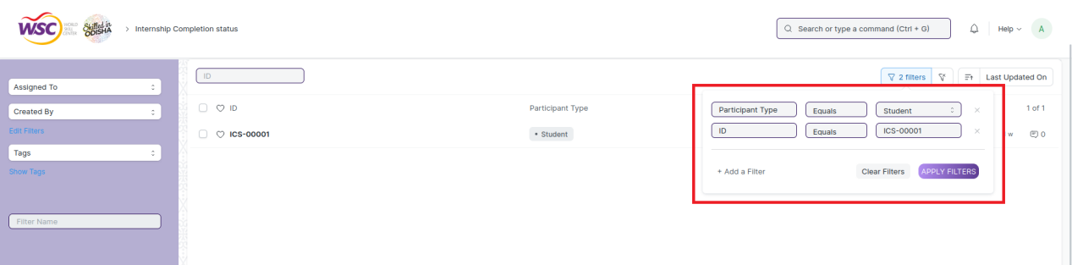

**Default Filters**

There are some filters present out of the box for the views which can be used for filtering the search results.

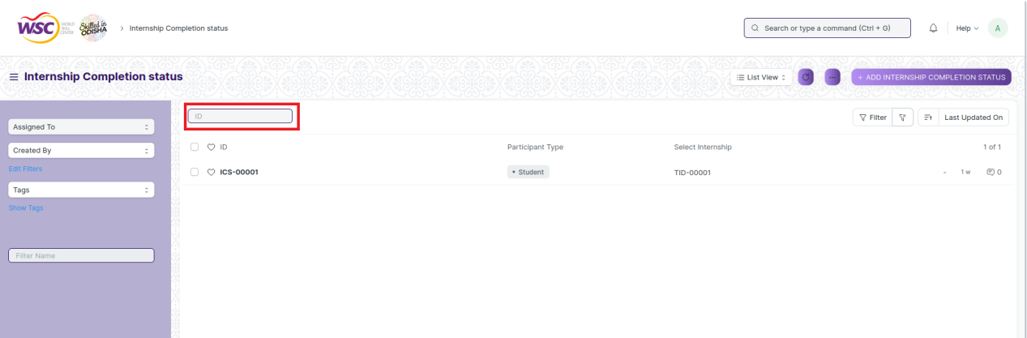

**Note :** The Filter Option can only be showed to the employees who have necessary permission.

## General Procedure for a Submittable Screen

### Create of New document

Login in to the system

Go the required workspace

Go to the required screen.

Click on the ***“+Add Screen Name”*** button in the right corner of the screen.

(Example : For addition in the new Internship Application , click +Add Internship Application button).

Enter the required information in the document.

Once you are finished entering the information , click the ***“Save”*** button.

After saving it , a submit button will appear.

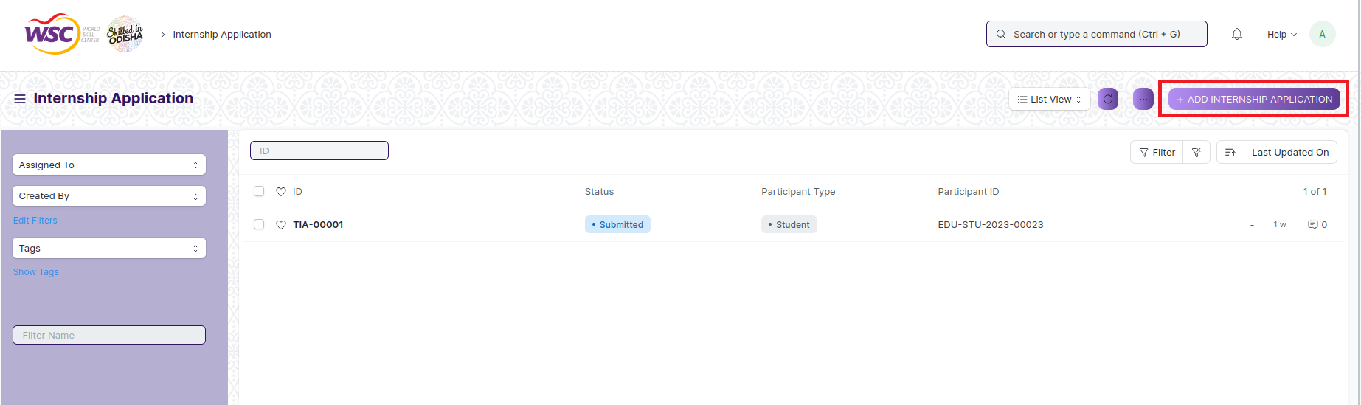

Click on the **“Submit”** button.

A confirmation dialog box will appear . Click the Yes button to submit the document.

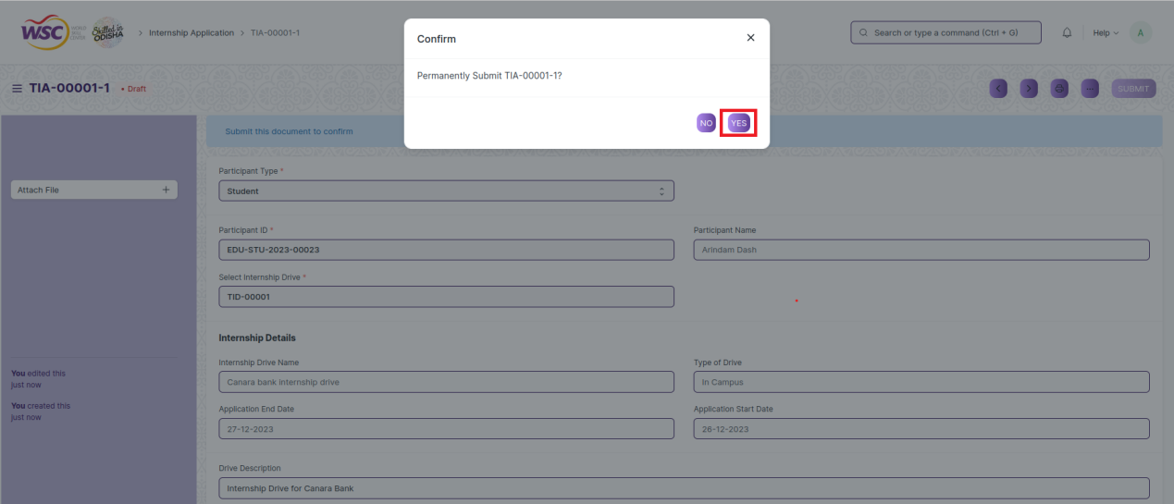

After submitting , the record will be visible in the List View of the screen.

**Note :** The process of creation can only be carried out by employees who have necessary permission.Kindly refer to the Screen wise permission section in the document.

### Cancel a Submitted Document

Log in to the system.

Go to the required workspace

Go to the required screen.

Click on the required document from the list view of the screen.

Click the ***“Cancel”*** Button .

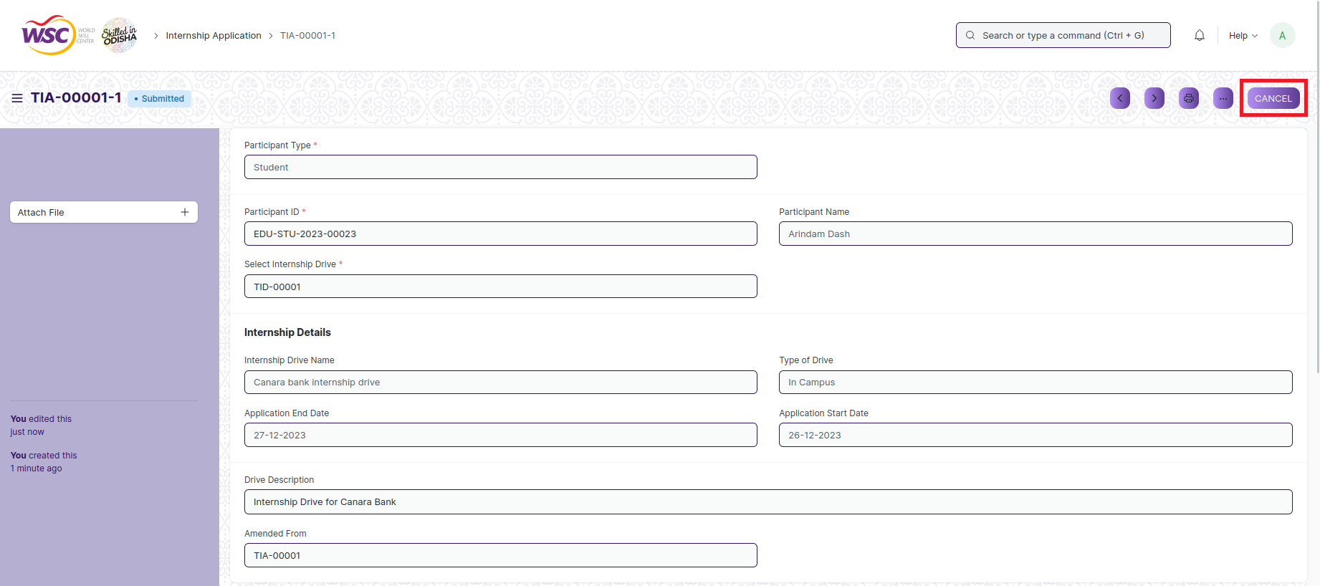

A confirmation dialog box will appear . Click the Yes button to cancel the document.

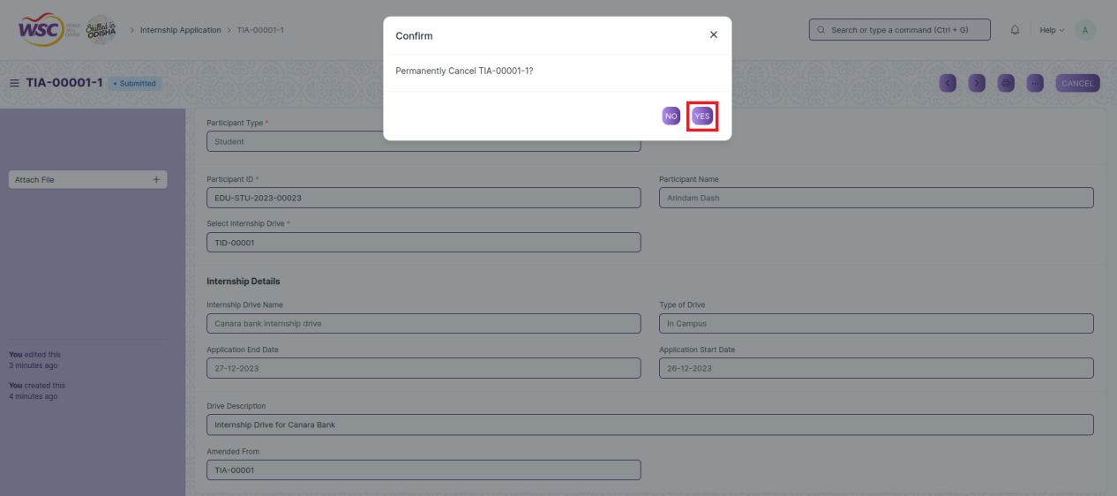

**Note :** The process of cancellation can only be carried out by employees who have necessary permission.Kindly refer to the Screen wise permission section in the document.

### Amend a Submittable Document

Log in to the system.

Go to the required workspace

Go to the required screen.

Click on the required document from the list view of the screen.

After cancellation of the document , an Amend button will appear on the screen.

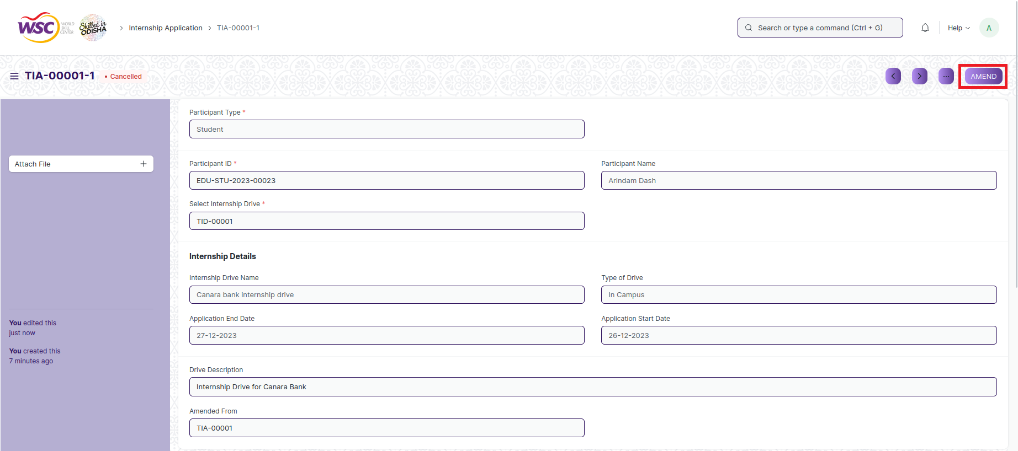

Click the “***Amend”*** button.

A new document will be created with the same information as the original document .

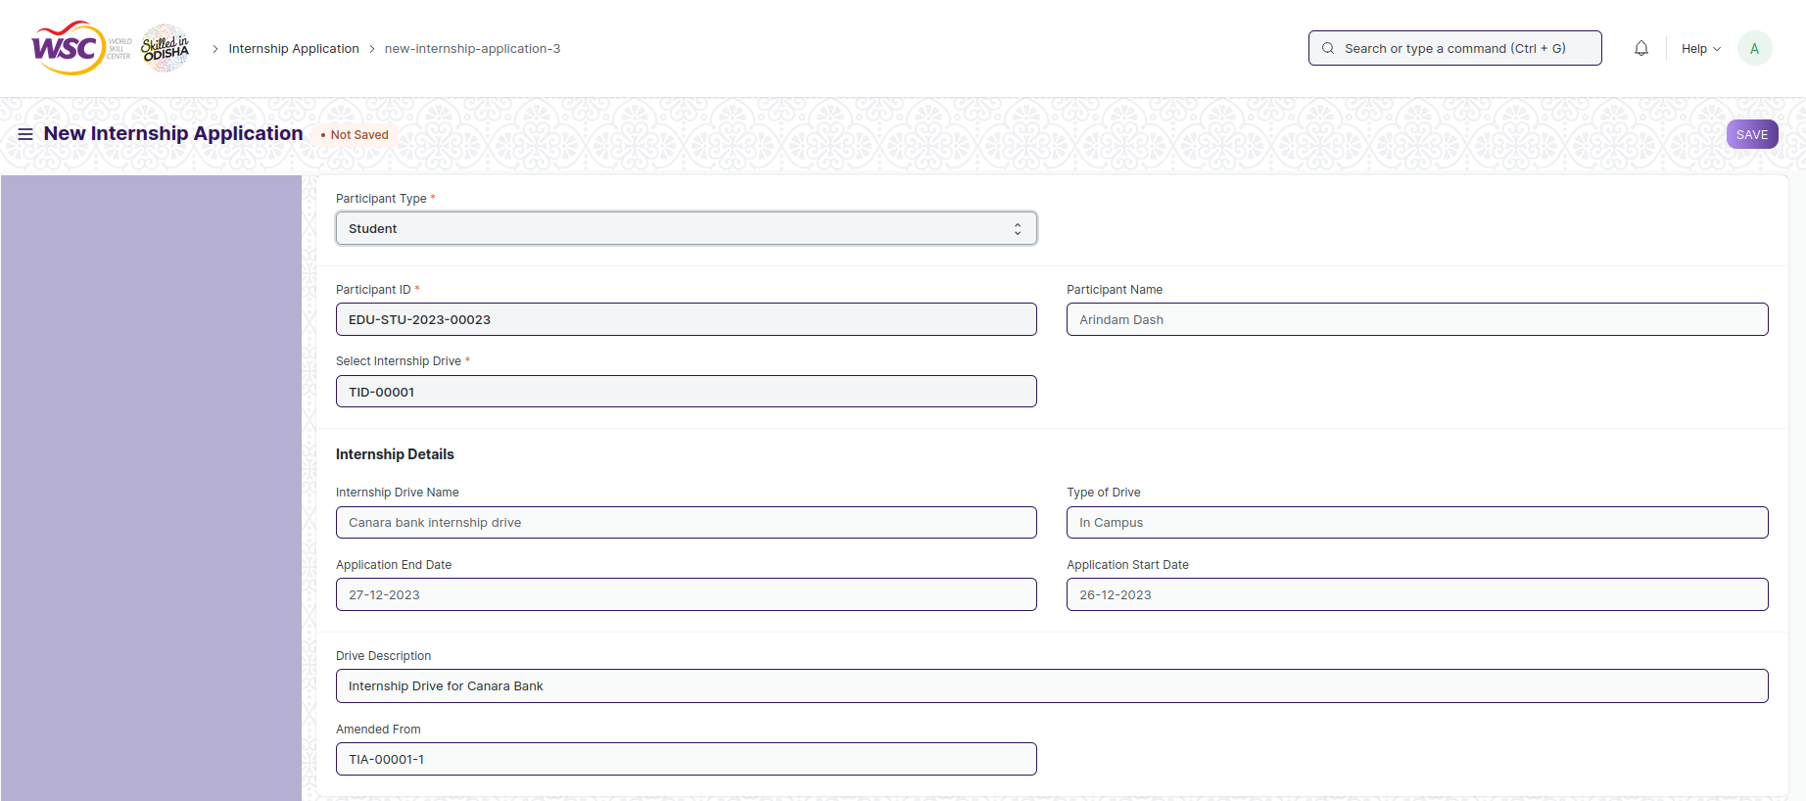

You can now make changes to the document as needed.

**Note :** The process of Amend can only be carried out by employees who have necessary permission.Kindly refer to the Screen wise permission section in the document.

### Action Menu on a document.

The three dots menu, located in the right corner of a document in a Screen , offers a range of actions and options to manage and interact with the document.

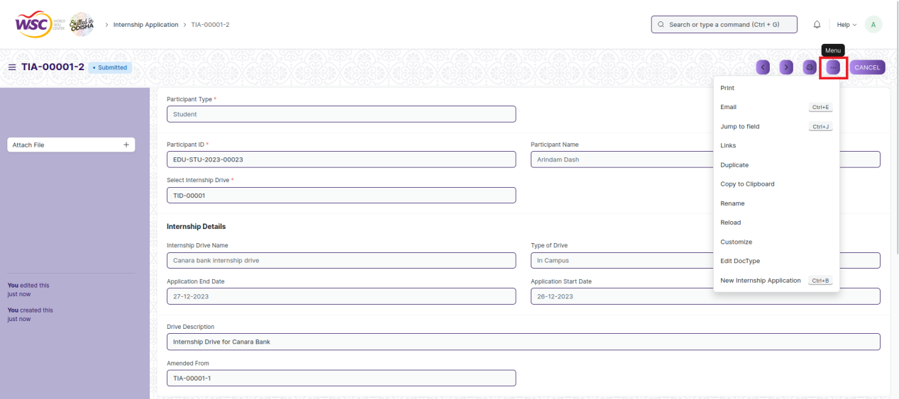

The functionalities available in the three dots menu are given below .

**Print :** Print Enables you to generate a printable version of the document ., which you can save as a PDF or send to a printer.

**Email :** Click on Email allows you to send the document as an attachment via email to specified recipients.

**Duplicate :** Create a new document with the same information as the current one.

**Delete :** Permanently remove the document.

**Cancel :** Cancel the submitted document.

**Submit :** Submit the document . If the document is submittable.

**Links :** This Option displays a list of document that are linked to the current document. You can navigate these linked documents from here.

**Jump to field :** You can directly go the required field by clicking this option and giving appropriate field name.

**Copy to Clipboard :** By clicking this option you can copy the content of the document .

**Rename :** By clicking the Rename option you can Rename the document.

**Note :** These options will be visible to employees who have necessary permission.

# Master

## Placement Company

**Description**

The "Placement Company" screen typically refers to a configuration or master data form where you define and manage records of different companies offering internships and job opportunities to the organizations students, within the system.

The screen is accessible to Training and Placement Administrator and Student.

To access the Placement Company Master screen ,go to :

***Home>Training and Placement>Masters>Placement Company***

**Screen**

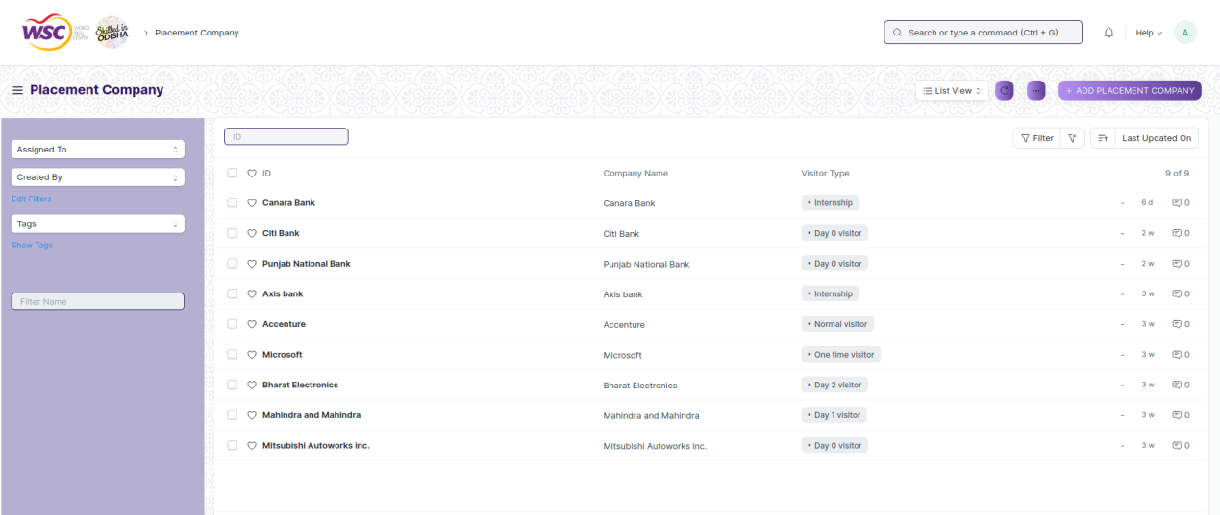

(List view of Placement Company)

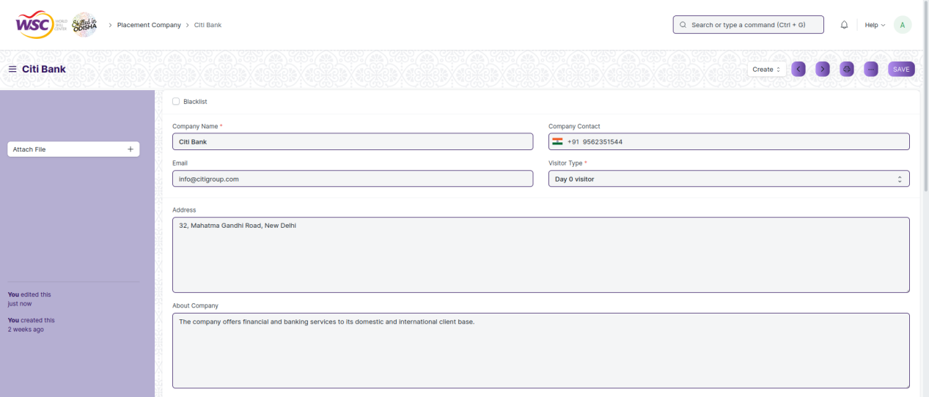

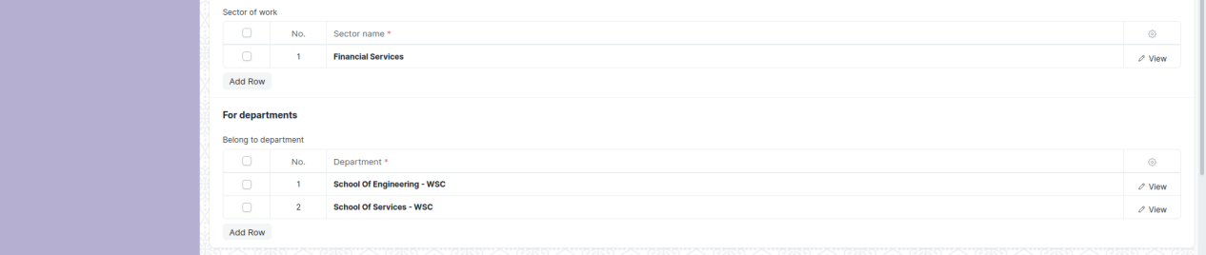

(View a saved record)

**Screen Type**

* Save

**Prerequisites**

* Not Available

**Adding a new record**

As it is a save screen, follow the general procedure to create a save document as mentioned above .

After creating a Placement Company , the record will be visible in the List view of the screen.

**Deleting a record**

As it a Save screen , follow the general procedure to delete a save document .

**Edit Record**

Follow the steps to view a saved Placement Company record.

Edit the field that you want to change.

Click on Save.

**Print Record**

As it is a Save screen , follow the general procedure to print a saved document.

**View Record in different format**

As it is a Save screen , follow the general procedure to view a saved document in different format.

## Entrepreneurship

**Description**

The "Entrepreneurship" screen typically refers to a configuration or master data form where you define and manage records of the organizations students who have started their own ventures within the system.

The screen is accessible to Training and Placement Administrator.

To access the Entrepreneurship Master screen ,go to :

***Home>Training and Placement>Masters>Entrepreneurship***

**Screen**

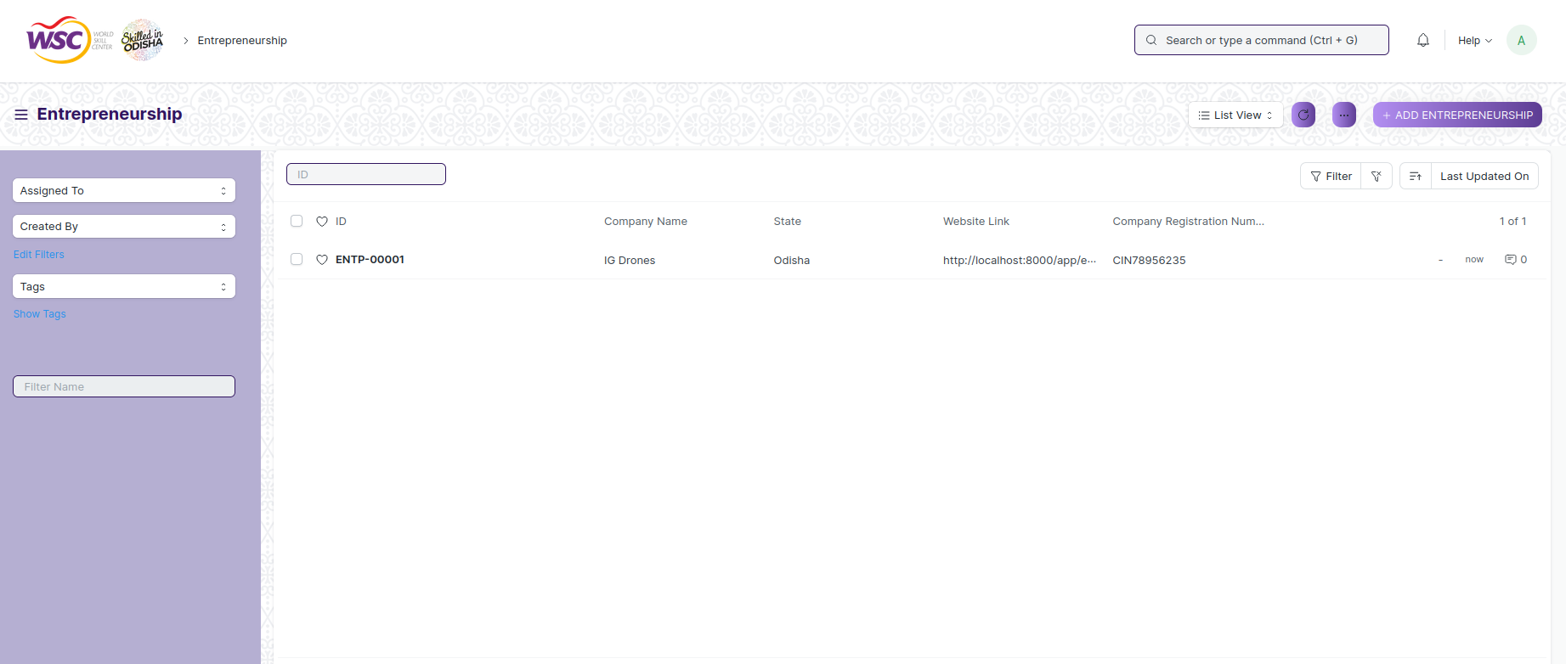

(List view of Entrepreneurship)

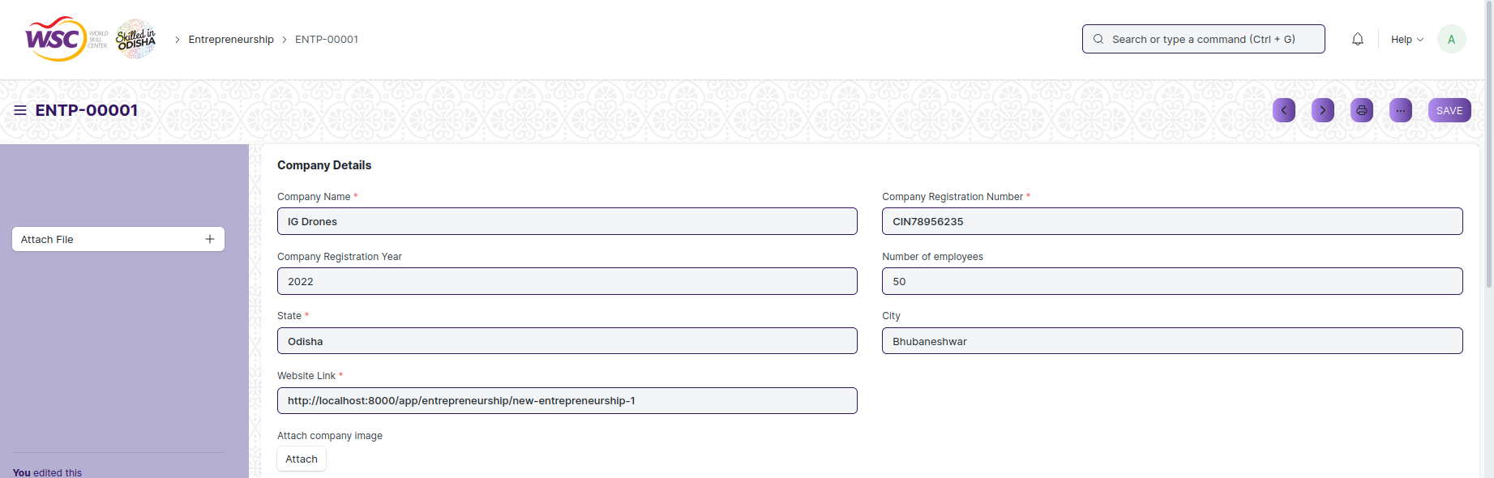

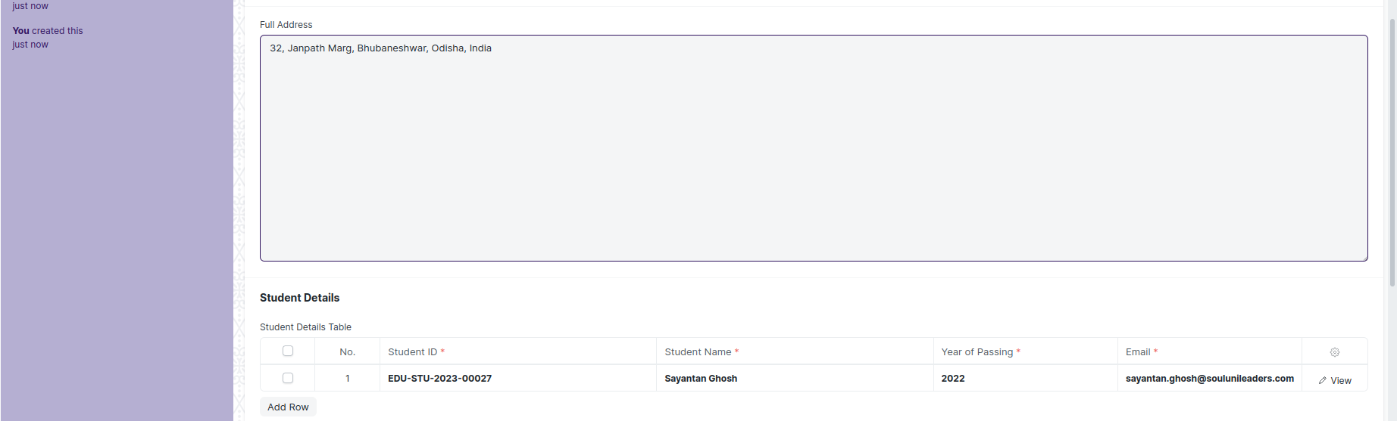



(View a saved record)

**Screen Type**

* Save

**Prerequisites**

* Not Available

**Adding a new record**

As it is a save screen, follow the general procedure to create a save document as mentioned above .

After creating an Entrepreneurship , the record will be visible in the List view of the screen.

**Deleting a record**

As it a Save screen , follow the general procedure to delete a save document .

**Edit Record**

Follow the steps to view a saved Entrepreneurship record.

Edit the field that you want to change.

Click on Save.

**Print Record**

As it is a Save screen , follow the general procedure to print a saved document.

**View Record in different format**

As it is a Save screen , follow the general procedure to view a saved document in different format.

## Sector

**Description**

The “Sector” screen typically refers to a configuration or master data form where you define and manage the records of the industrial sectors that a company might work in.

The screen is accessible to Training and Placement Administrator.

To access the Sector Master screen ,go to :

***Home>Training and Placement>Masters>Sector***

**Screen**



(List view of Sector)







(View a saved record)

**Screen Type**

* Save

**Prerequisites**

* Not Available

**Adding a new record**

As it is a save screen, follow the general procedure to create a save document as mentioned above .

After creating an Sector , the record will be visible in the List view of the screen.

**Deleting a record**

As it a Save screen , follow the general procedure to delete a save document .

**Edit Record**

Follow the steps to view a saved sector record.

Edit the field that you want to change.

Click on Save.

**Print Record**

As it is a Save screen , follow the general procedure to print a saved document.

**View Record in different format**

As it is a Save screen , follow the general procedure to view a saved document in different format.

## Resume

**Description**

The “Resume” screen typically refers to a configuration or master data form where you define and manage the records of the industrial sectors that a company might work in.

The screen is accessible to Training and Placement Administrator and Student.

To access the Resume Master screen ,go to :

***Home>Training and Placement>Masters>Resume***

**Screen**

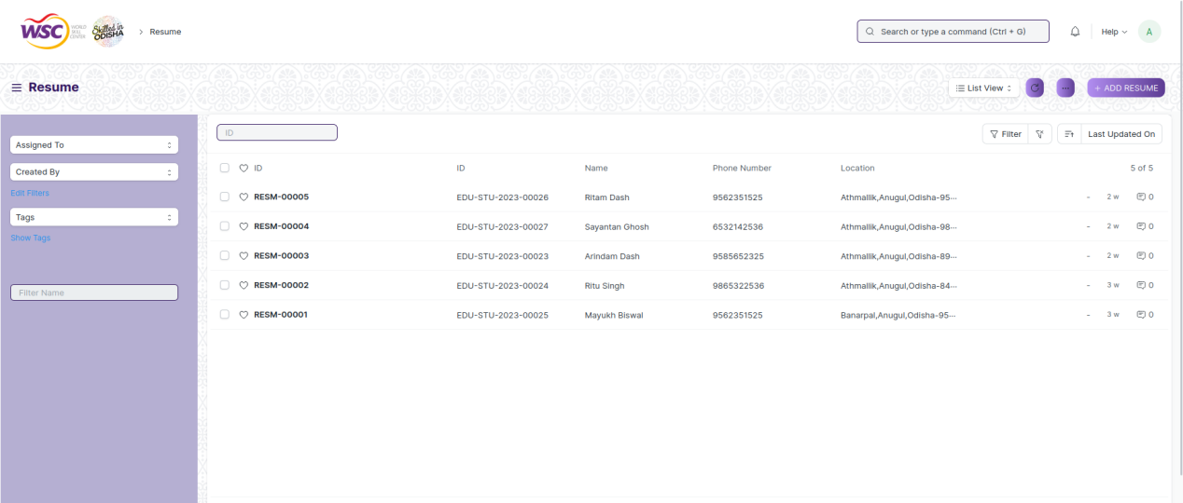

(List view of Resume)







(View a saved record)

**Screen Type**

* Save

**Prerequisites**

* Not Available

**Adding a new record**

As it is a save screen, follow the general procedure to create a save document as mentioned above .

After creating a resume , the record will be visible in the List view of the screen.

**Deleting a record**

As it a Save screen , follow the general procedure to delete a save document .

**Edit Record**

Follow the steps to view a saved resume record.

Edit the field that you want to change.

Click on Save.

**Print Record**

As it is a Save screen , follow the general procedure to print a saved document.

**View Record in different format**

As it is a Save screen , follow the general procedure to view a saved document in different format.

# Training Events

## TnP Program

**Description**

The "TnP Program" screen typically refers to a configuration or master data form where you define and manage different training and placement Programs within the system.

The screen is accessible to Training and Placement Administrator and Student and Students.

To access the TnP Program screen ,go to :

***Home>Training and Placement>Training Events>TnP Program***

**Screen**

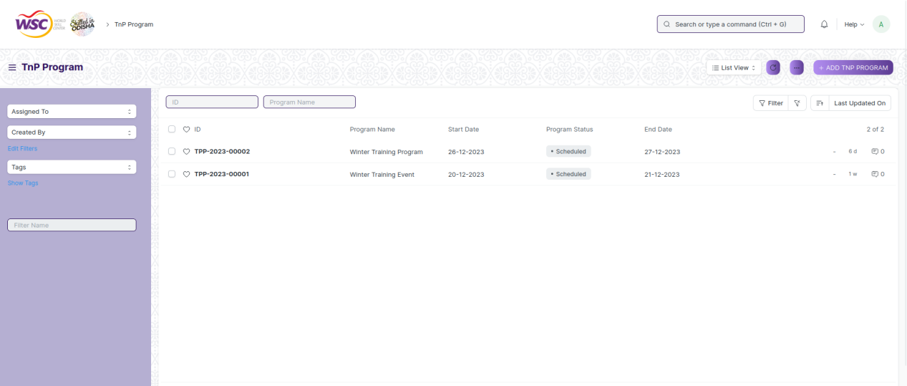

(List view of TnP Program)

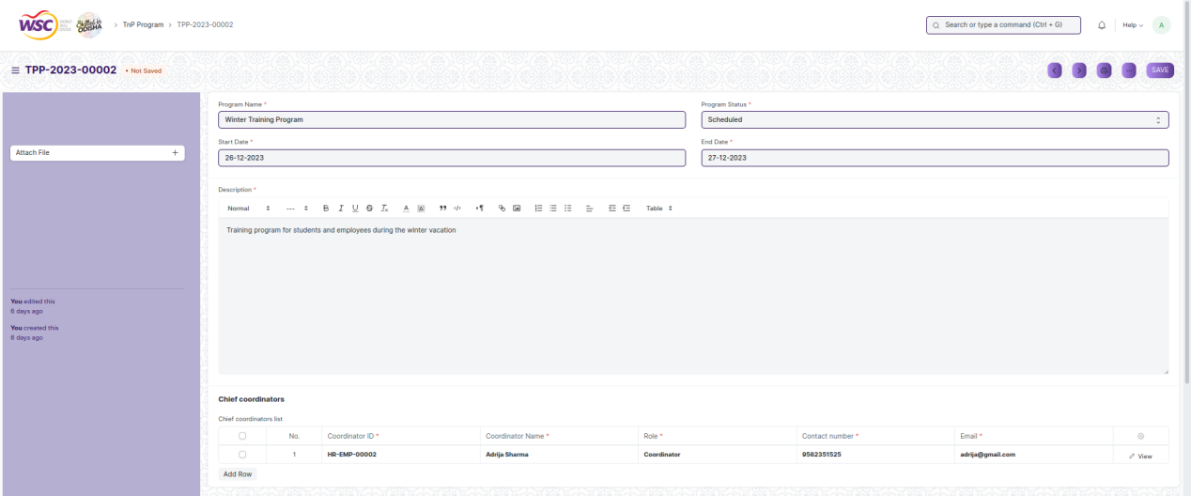

(View a saved record)

**Screen Type**

* Save

**Prerequisites**

* Not Available

**Adding a new record**

As it is a save screen, follow the general procedure to create a save document as mentioned above .

After creating a TnP Program , the record will be visible in the List view of the screen.

**Deleting a record**

As it a Save screen , follow the general procedure to delete a save document .

**Edit Record**

Follow the steps to view a saved TnP Program record.

Edit the field that you want to change.

Click on Save.

**Print Record**

As it is a Save screen , follow the general procedure to print a saved document.

**View Record in different format**

As it is a Save screen , follow the general procedure to view a saved document in different format.

## TnP Event

**Description**

The "TnP Event" screen typically refers to a configuration or master data form where you define and manage different types of training and placement events within the system.

The screen is accessible to Training and Placement Administrator and Students.

To access the TnP Event screen ,go to :

***Home>Training and Placement>Training Events>TnP Event***

**Screen**

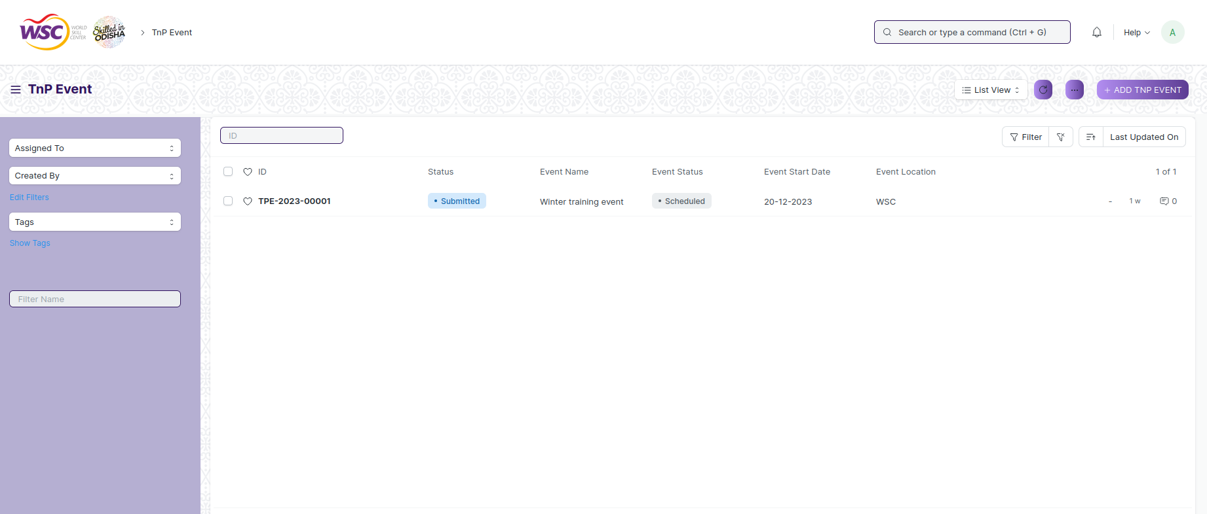

(List view of TnP Event)

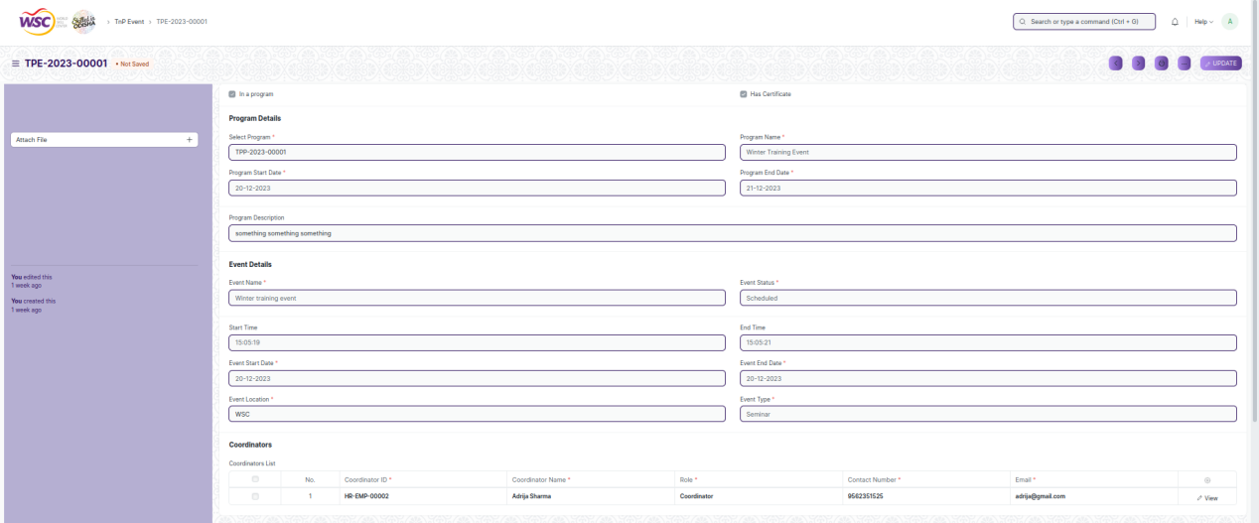

(View a saved record)

**Screen Type**

* Submit

**Prerequisites**

* Record of the placement company for which the placement drive is being created must be created first.

**Adding a new record**

As it is a submittable screen follow the general procedure to create a submittable document as mentioned above.

**Deleting a record**

If the document is not submitted , it is in draft state , you can delete the document by following the procedure to delete a save document.

If the document is submitted, follow the procedure to delete the submittable document.

**Amend record**

As it is a submittable screen , follow the general procedure to Amend the document.

**Edit record**

If the document is in draft state , the document can be editable.

Once the document is submitted , it cannot be edited.

**Print record**

Follow the general procedure to print a saved document.

**View record in different format**

Follow the general procedure to view a saved document in different format.

## Participant Registration

**Description**

The "Participant Registration" screen typically refers to a configuration or master data form where you define and manage registration records of participants for training and placement events within the system.

The screen is accessible to Training and Placement Administrator, Employees and Students.

To access the Participant Registration screen ,go to :

***Home>Training and Placement>Training Events>Participant Registration***

**Screen**

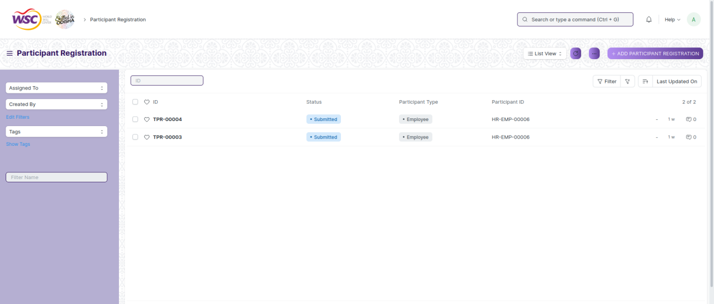

(List view of Participant Registration)

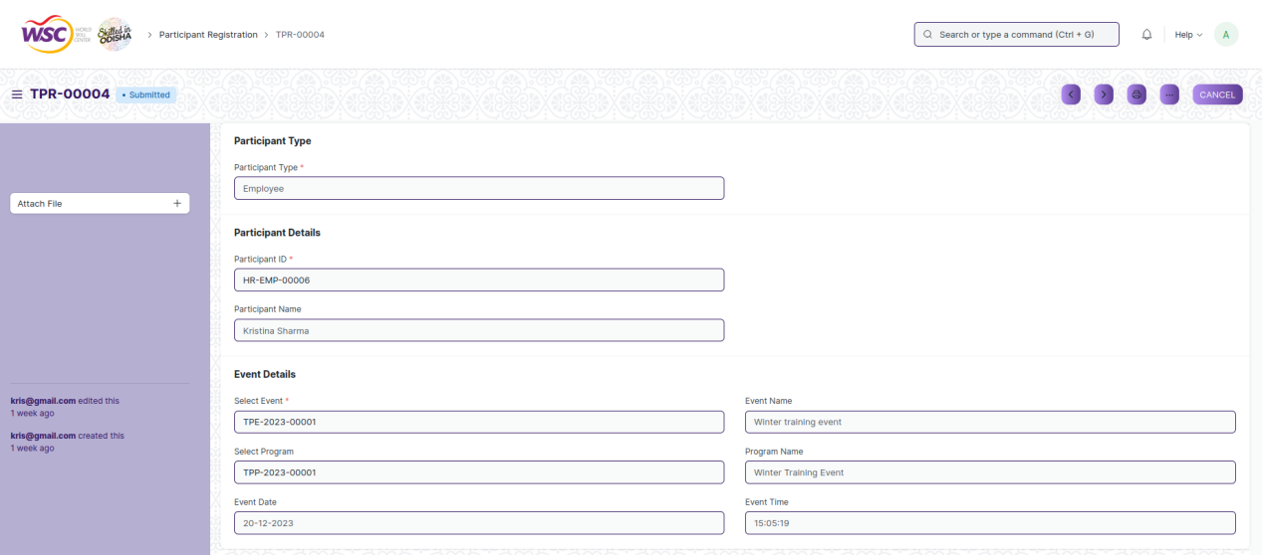

(View a saved record)

**Screen Type**

* Submit

**Prerequisites**

* Record of the placement company for which the placement drive is being created must be created first.

**Adding a new record**

As it is a submittable screen follow the general procedure to create a submittable document as mentioned above.

**Deleting a record**

If the document is not submitted , it is in draft state , you can delete the document by following the procedure to delete a save document.

If the document is submitted, follow the procedure to delete the submittable document.

**Amend record**

As it is a submittable screen , follow the general procedure to Amend the document.

**Edit record**

If the document is in draft state , the document can be editable.

Once the document is submitted , it cannot be edited.

**Print record**

Follow the general procedure to print a saved document.

**View record in different format**

Follow the general procedure to view a saved document in different format.

## Participant Attendance

**Description**

The "Participant Attendance" screen typically refers to a configuration or master data form where you define and manage attendance records of participant attendance for a training and placement event within the system.

The screen is accessible to Training and Placement Administrator Employees and Students

To access the Participant Attendance screen ,go to :

***Home>Training and Placement>Training Events>Participant Attendance***

**Screen**

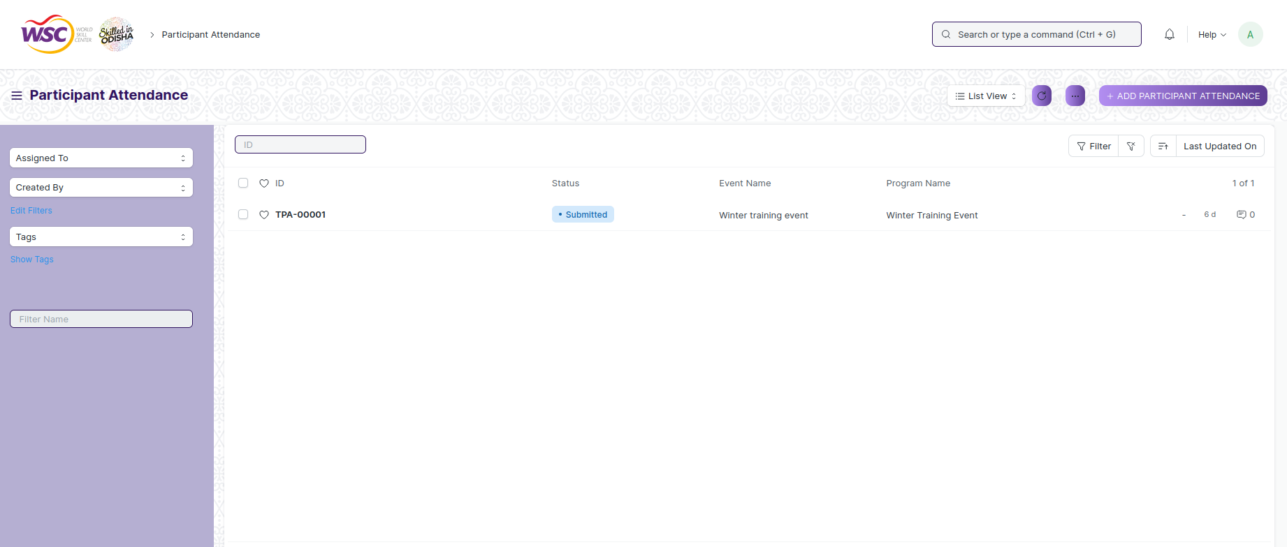

(List view of Participant Attendance)

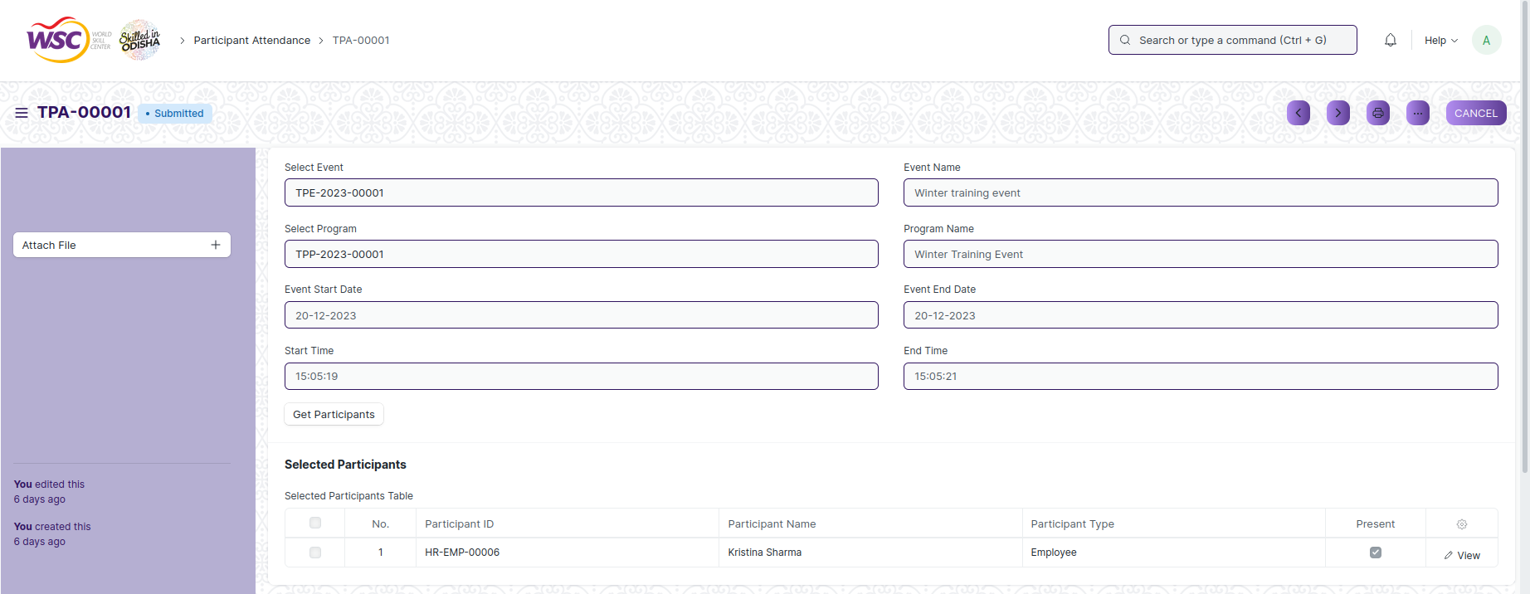

(View a saved record)

**Screen Type**

* Submit

**Prerequisites**

* Record of the placement company for which the placement drive is being created must be created first.

**Adding a new record**

As it is a submittable screen follow the general procedure to create a submittable document as mentioned above.

**Deleting a record**

If the document is not submitted , it is in draft state , you can delete the document by following the procedure to delete a save document.

If the document is submitted, follow the procedure to delete the submittable document.

**Amend record**

As it is a submittable screen , follow the general procedure to Amend the document.

**Edit record**

If the document is in draft state , the document can be editable.

Once the document is submitted , it cannot be edited.

**Print record**

Follow the general procedure to print a saved document.

**View record in different format**

Follow the general procedure to view a saved document in different format.

## Event Feedback

**Description**

The "Event Feedback" screen typically refers to a configuration or master data form where you define and manage records of feedback given for an training and placement event, within the system.

The screen is accessible to Training and Placement Administrator Employees and Students.

To access the Event Feedback screen ,go to :

***Home>Training and Placement>Training Events>Event Feedback***

**Screen**

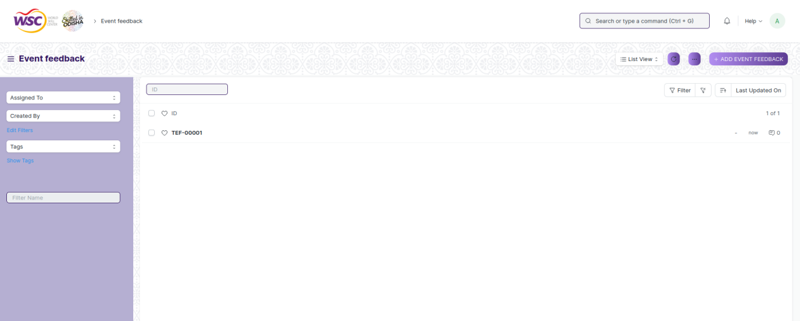

(List view of Event Feedback)

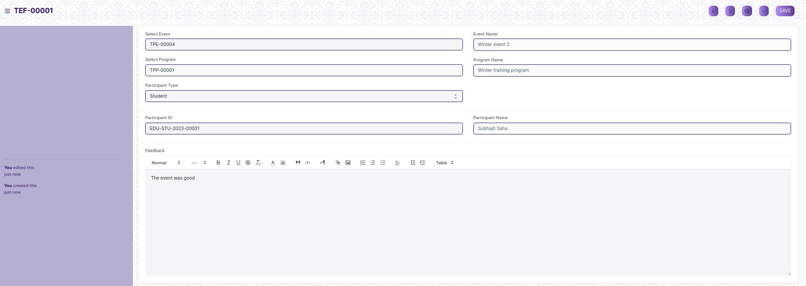

(View a saved record)

**Screen Type**

* Save

**Prerequisites**

* Record of the TnP Event for which the feedback is being given must be created first.

**Adding a new record**

As it is a save screen, follow the general procedure to create a save document as mentioned above .

After creating an event feedback , the record will be visible in the List view of the screen.

**Deleting a record**

As it a Save screen , follow the general procedure to delete a save document .

**Edit Record**

Follow the steps to view a saved employment type.

Edit the field that you want to change.

Click on Save.

**Print Record**

As it is a Save screen , follow the general procedure to print a saved document.

**View Record in different format**

As it is a Save screen , follow the general procedure to view a saved document in different format.

## Generate Certificate Tool

**Description**

The "Generate Certificate Tool" screen typically refers to a configuration or master data form where you define, manage and generate certificate records in bulk for all the eligible participants of a training and placement events, within the system.

The screen is accessible to Training and Placement Administrator.

To access the Generate Certificate Tool screen ,go to :

***Home>Training and Placement>Training Events>Generate Certificate Tool***

**Screen**

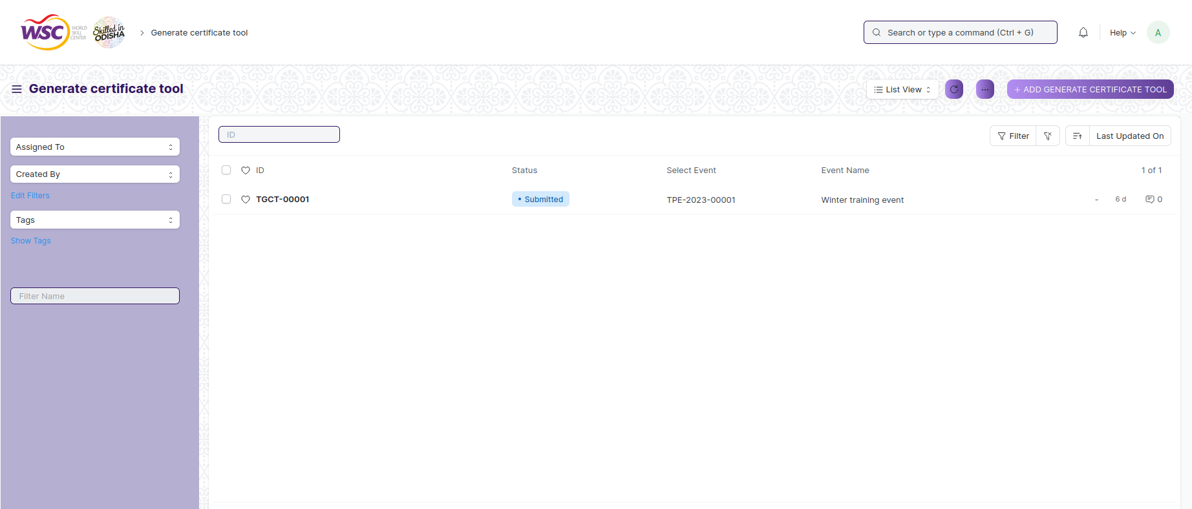

(List view of Generate Certificate Tool)

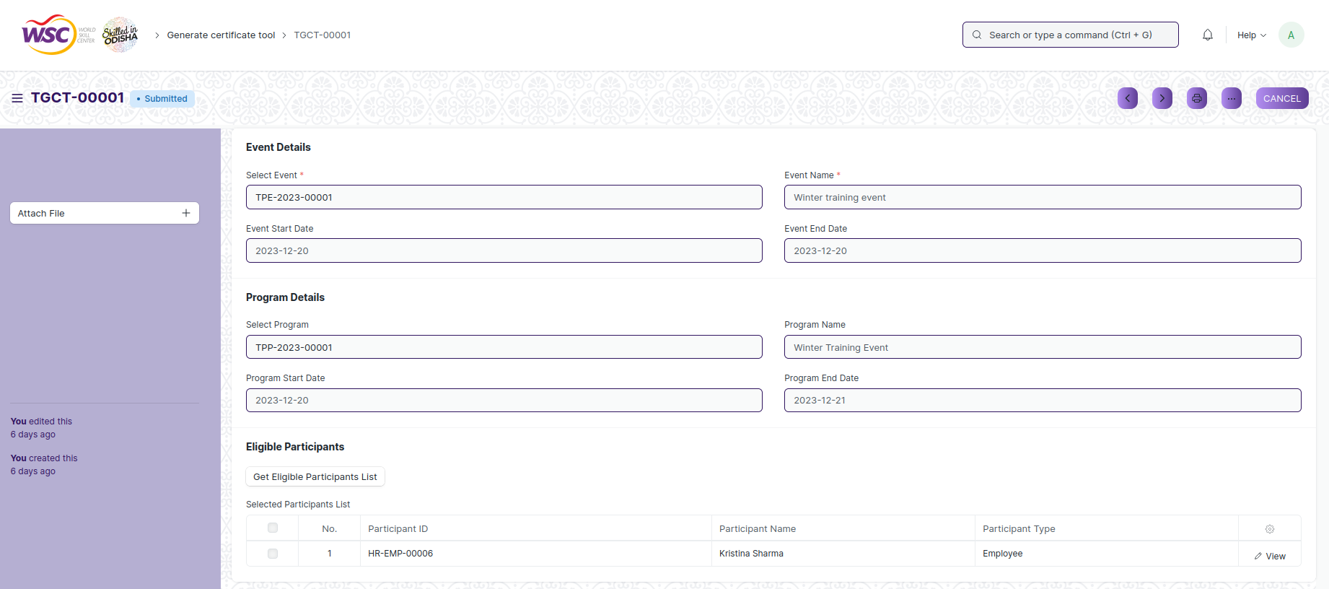

(new record screen)

**Screen Type**

* Submit

**Prerequisites**

* Record of the placement company for which the placement drive is being created must be created first.

**Adding a new record**

As it is a submittable screen follow the general procedure to create a submittable document as mentioned above.

**Deleting a record**

If the document is not submitted , it is in draft state , you can delete the document by following the procedure to delete a save document.

If the document is submitted, follow the procedure to delete the submittable document.

**Amend record**

As it is a submittable screen , follow the general procedure to Amend the document.

**Edit record**

If the document is in draft state , the document can be editable.

Once the document is submitted , it cannot be edited.

**Print record**

Follow the general procedure to print a saved document.

**View record in different format**

Follow the general procedure to view a saved document in different format.

## Generate Certificate

**Description**

The "Generate Certificate" screen typically refers to a configuration or master data form where you define, manage and generate certificate records for training and placement records within the system

The screen is accessible to Training and Placement Administrator.

To access the Generate Certificate screen ,go to :

***Home>Training and Placement>Training Events>Generate Certificate***

**Screen**

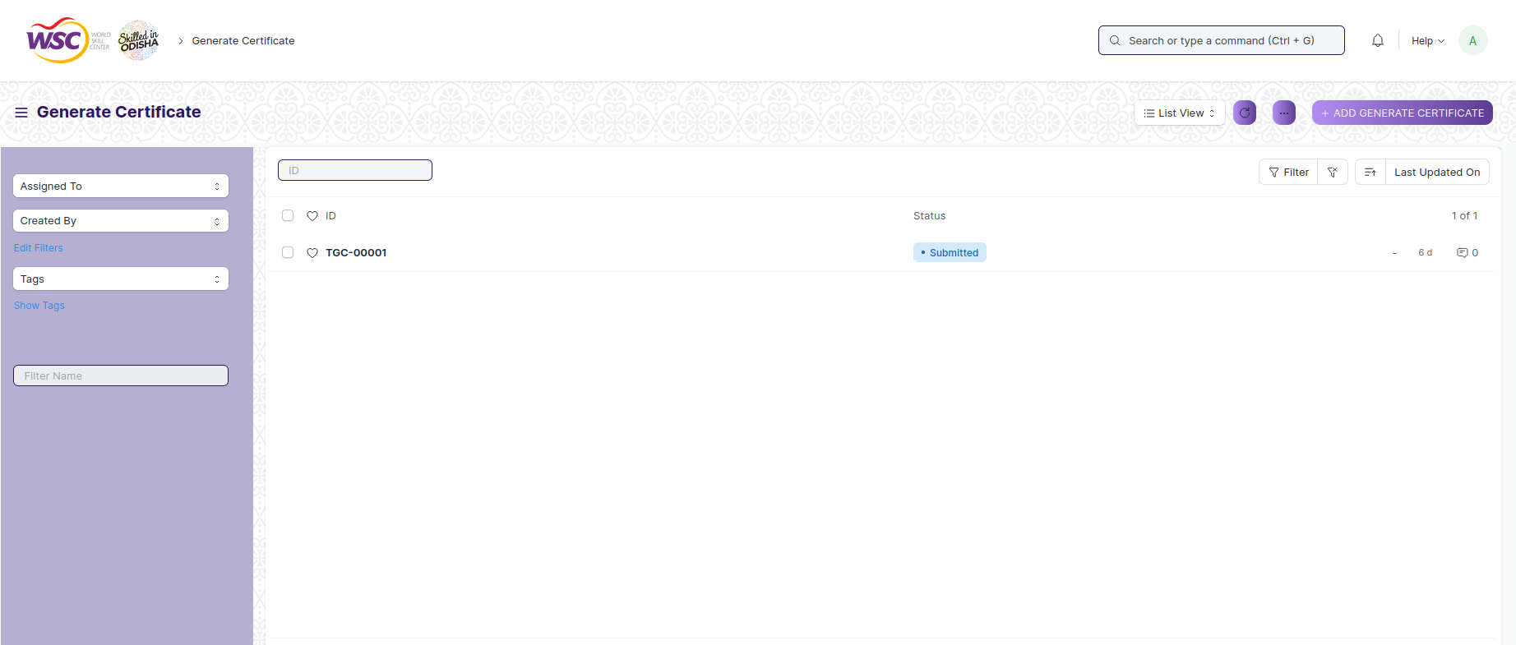

(List view of Generate Certificate)

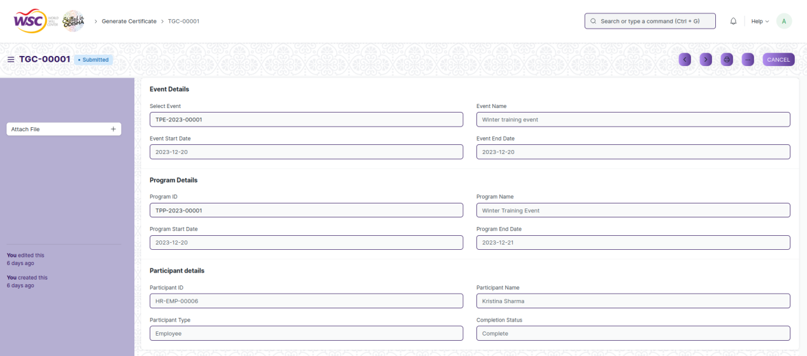

(View a saved record)

**Screen Type**

* Submit

**Prerequisites**

* Record of the placement company for which the placement drive is being created must be created first.

**Adding a new record**

As it is a submittable screen follow the general procedure to create a submittable document as mentioned above.

**Deleting a record**

If the document is not submitted , it is in draft state , you can delete the document by following the procedure to delete a save document.

If the document is submitted, follow the procedure to delete the submittable document.

**Amend record**

As it is a submittable screen , follow the general procedure to Amend the document.

**Edit record**

If the document is in draft state , the document can be editable.

Once the document is submitted , it cannot be edited.

**Print record**

Follow the general procedure to print a saved document.

**View record in different format**

Follow the general procedure to view a saved document in different format.

# Internships

## Internship Drive

**Description**

The "Internship Drive" screen typically refers to a configuration or master data form where you define and manage records of different internship drives within the system.

The screen is accessible to Training and Placement Administrator, Employees and Students.

To access the Internships screen ,go to :

***Home>Training and Placement>Internships>Internship Drive***

**Screen**

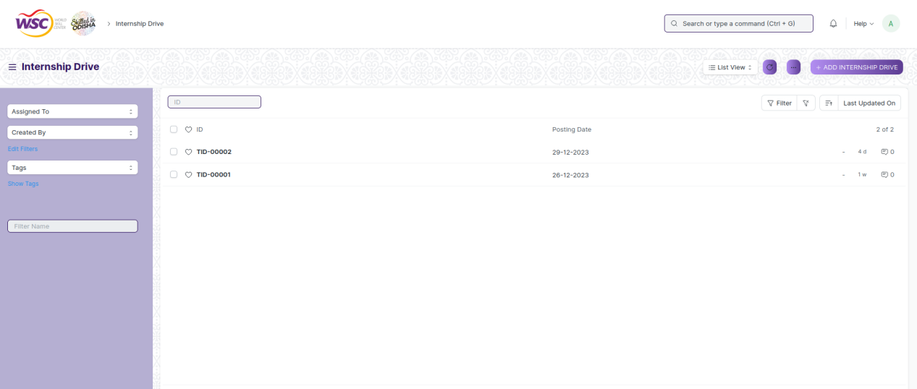

(List view of Internship Drive)

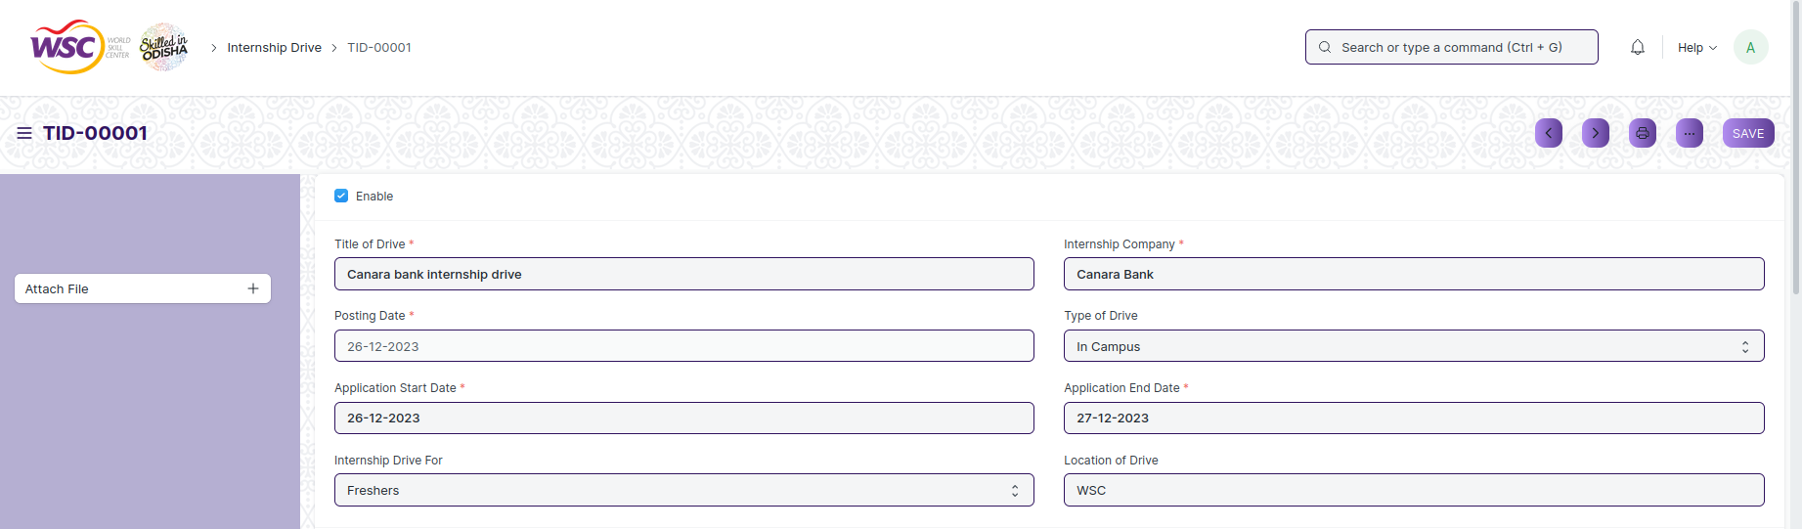

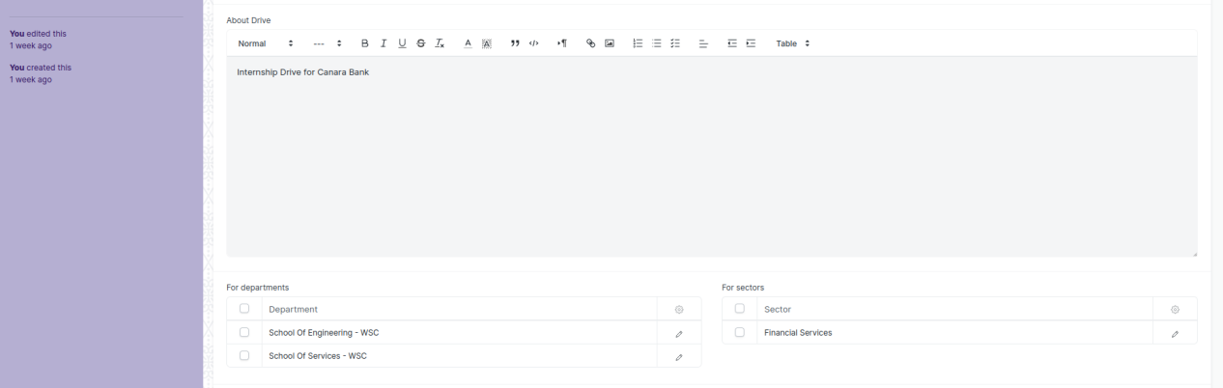

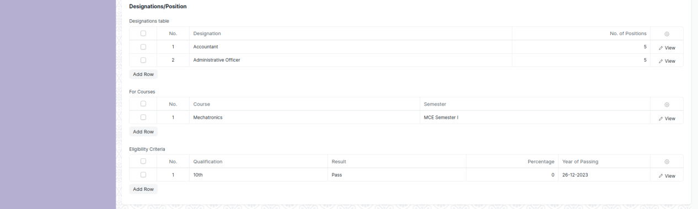

(View a saved record)

**Screen Type**

* Save

**Prerequisites**

* Record of the TnP Event for which the feedback is being given must be created first.

**Adding a new record**

As it is a save screen, follow the general procedure to create a save document as mentioned above .

After creating an event feedback , the record will be visible in the List view of the screen.

**Deleting a record**

As it a Save screen , follow the general procedure to delete a save document .

**Edit Record**

Follow the steps to view a saved internship drive record.

Edit the field that you want to change.

Click on Save.

**Print Record**

As it is a Save screen , follow the general procedure to print a saved document.

**View Record in different format**

As it is a Save screen , follow the general procedure to view a saved document in different format.

## Internship Application

**Description**

The "Internship Application" screen typically refers to a configuration or master data form where you define and manage records of different internship applications within the system.

The screen is accessible to Training and Placement Administrator, Employees and Students.

To access the Employment Type Master screen ,go to :

***Home>Training and Placement>Internships>Internship Application***

**Screen**

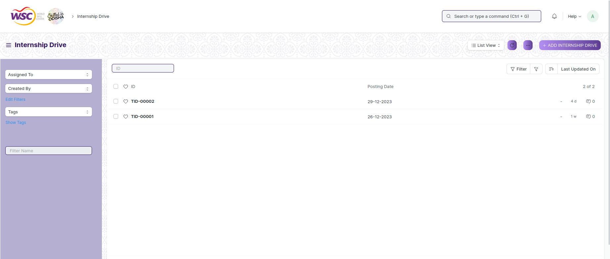

(List view of Internship Application)

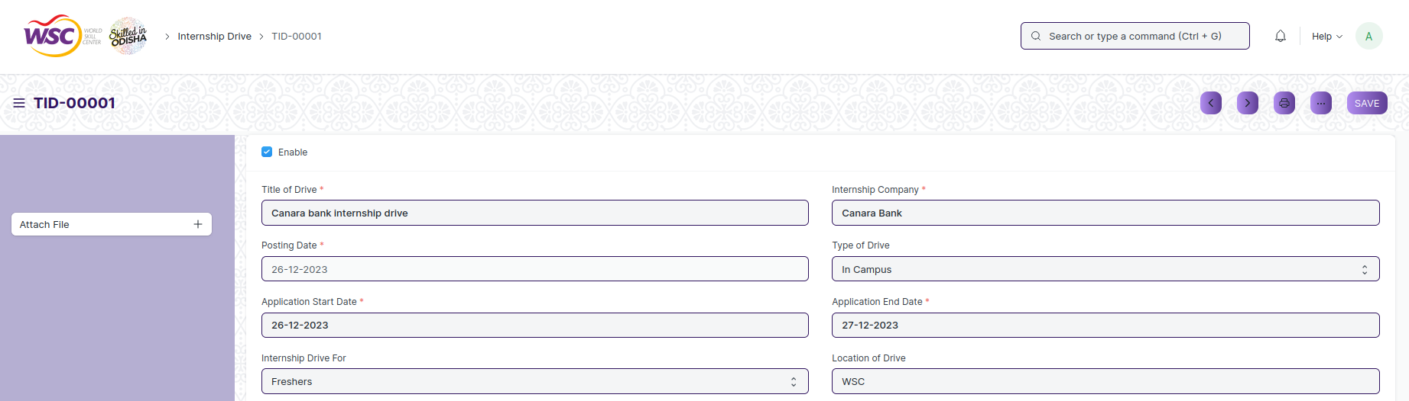

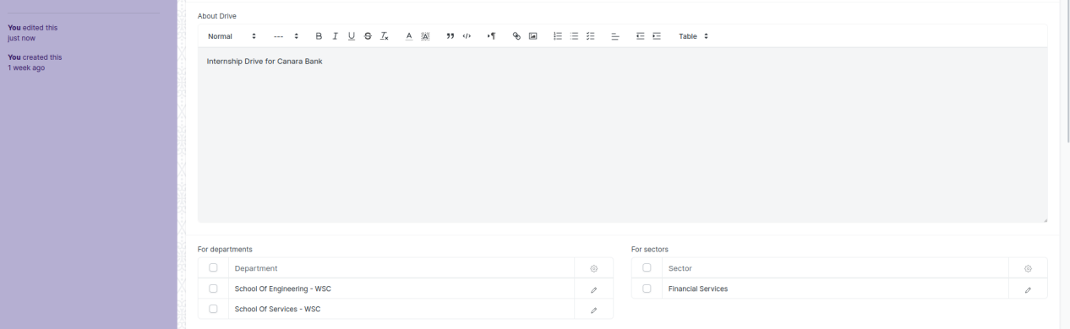

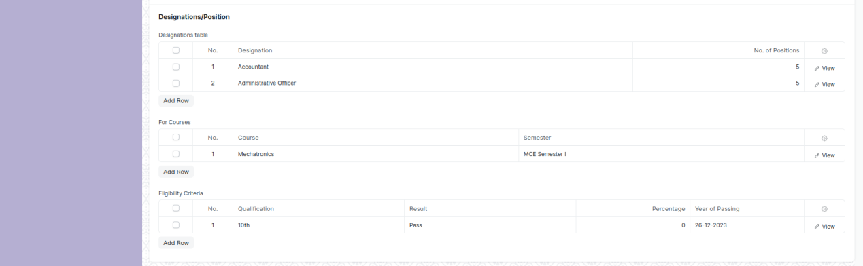

(View a saved record)

**Screen Type**

* Submit

**Prerequisites**

* Record of the placement company for which the placement drive is being created must be created first.

**Adding a new record**

As it is a submittable screen follow the general procedure to create a submittable document as mentioned above.

**Deleting a record**

If the document is not submitted , it is in draft state , you can delete the document by following the procedure to delete a save document.

If the document is submitted, follow the procedure to delete the submittable document.

**Amend record**

As it is a submittable screen , follow the general procedure to Amend the document.

**Edit record**

If the document is in draft state , the document can be editable.

Once the document is submitted , it cannot be edited.

**Print record**

Follow the general procedure to print a saved document.

**View record in different format**

Follow the general procedure to view a saved document in different format.

## Internship Participant Selection

**Description**

The “Internship Participant Selection” screen typically refers to a configuration or master data form where you define and manage records of participants who are going to be or have been selected for an internship from the pool of applicants to the internship, within the system.

The screen is accessible to Training and Placement Administrator.

To access the Internship Participant Selection screen ,go to :

***Home>Training and Placement>Internships>Internship Participant Selection***

**Screen**

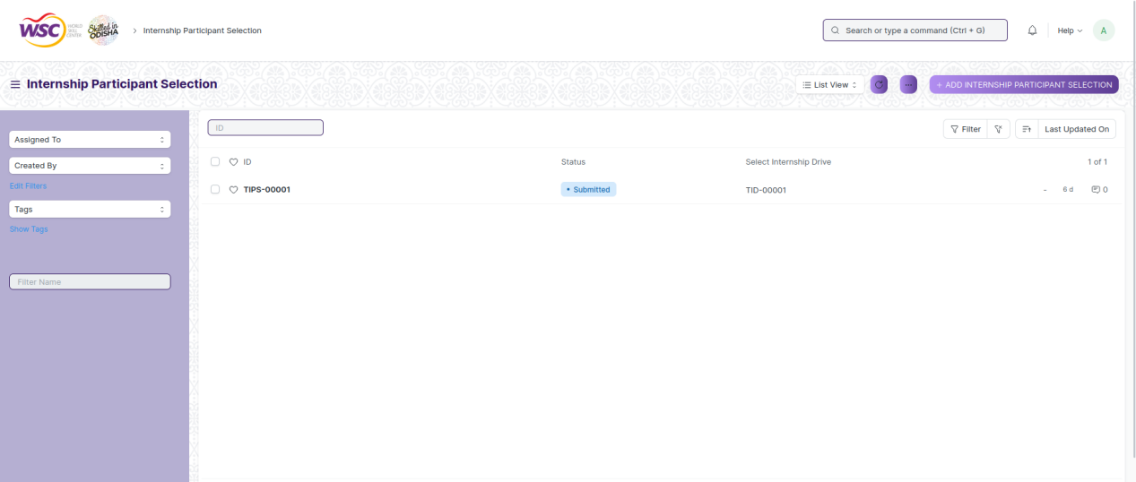

(List view of Internship Participant Selection)

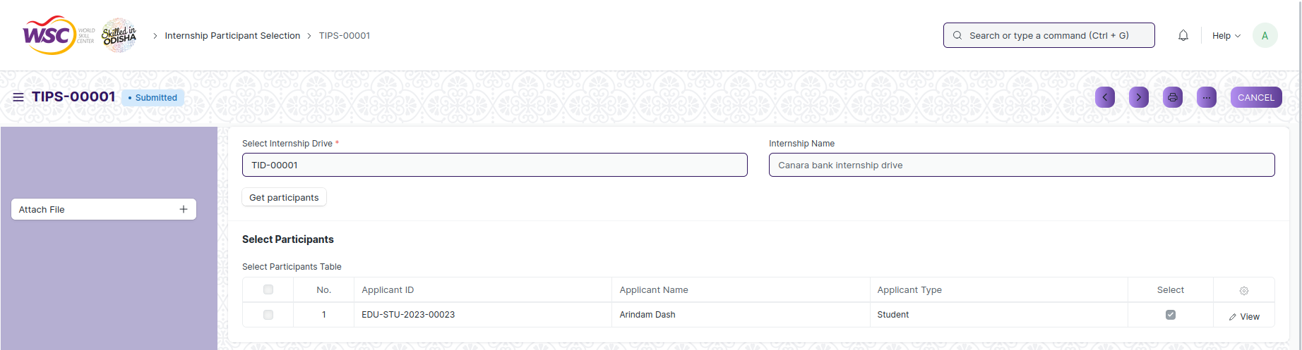

(View a saved record)

**Screen Type**

* Submit

**Prerequisites**

* Record of the placement company for which the placement drive is being created must be created first.

**Adding a new record**

As it is a submittable screen follow the general procedure to create a submittable document as mentioned above.

**Deleting a record**

If the document is not submitted , it is in draft state , you can delete the document by following the procedure to delete a save document.

If the document is submitted, follow the procedure to delete the submittable document.

**Amend record**

As it is a submittable screen , follow the general procedure to Amend the document.

**Edit record**

If the document is in draft state , the document can be editable.

Once the document is submitted , it cannot be edited.

**Print record**

Follow the general procedure to print a saved document.

**View record in different format**

Follow the general procedure to view a saved document in different format.

## Internship Final List Declaration

**Description**

The "Internship Final List Declaration" screen typically refers to a configuration or master data form where you define and manage records of the final list of applicants who have been selected for an internship, within the system.

The screen is accessible to Training and Placement Administrator Employees and Students.

To access the Internship Final List Declaration screen ,go to :

***Home>Training and Placement>Internships>Internship Final List Declaration***

**Screen**

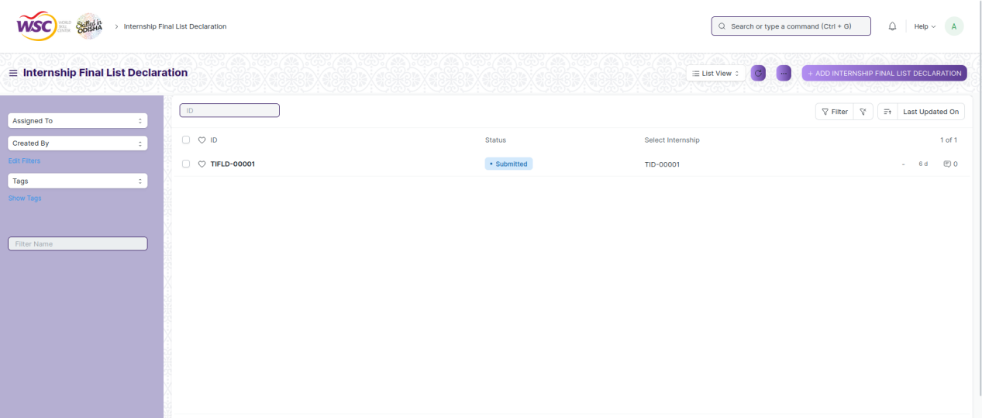

(List view of Internship Final List Declaration)

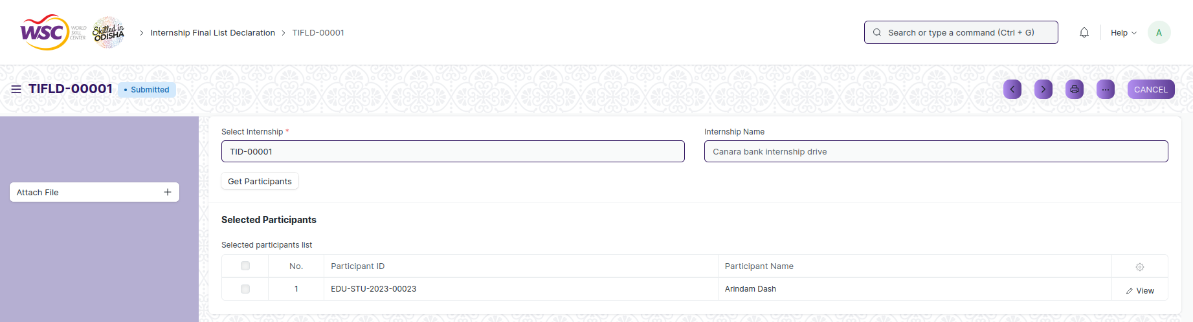

(View a saved record)

**Screen Type**

* Submit

**Prerequisites**

* Record of the placement company for which the placement drive is being created must be created first.

**Adding a new record**

As it is a submittable screen follow the general procedure to create a submittable document as mentioned above.

**Deleting a record**

If the document is not submitted , it is in draft state , you can delete the document by following the procedure to delete a save document.

If the document is submitted, follow the procedure to delete the submittable document.

**Amend record**

As it is a submittable screen , follow the general procedure to Amend the document.

**Edit record**

If the document is in draft state , the document can be editable.

Once the document is submitted , it cannot be edited.

**Print record**

Follow the general procedure to print a saved document.

**View record in different format**

Follow the general procedure to view a saved document in different format.

## Internship Completion Status

**Description**

The "Internship Completion Status" screen typically refers to a configuration or master data form where you define and manage records which define whether a participant has completed an internship or not, within the system.

The screen is accessible to Training and Placement Administrator.

To access the Internship Completion Status screen ,go to :

***Home>Training and Placement>Internships>Internship Completion Status***

**Screen**

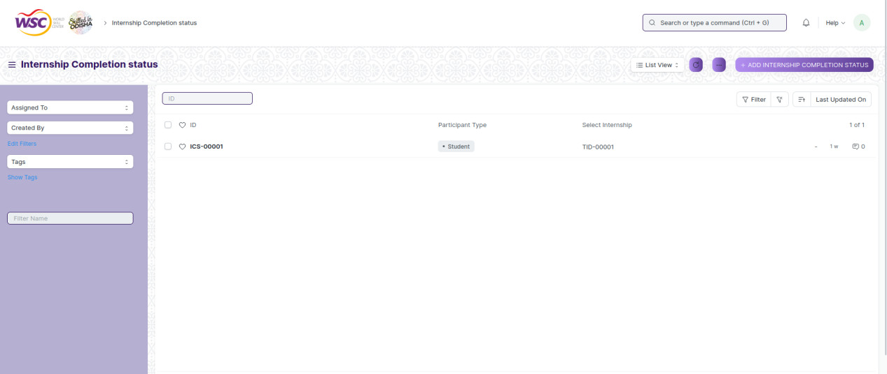

(List view of Internship Completion Status)

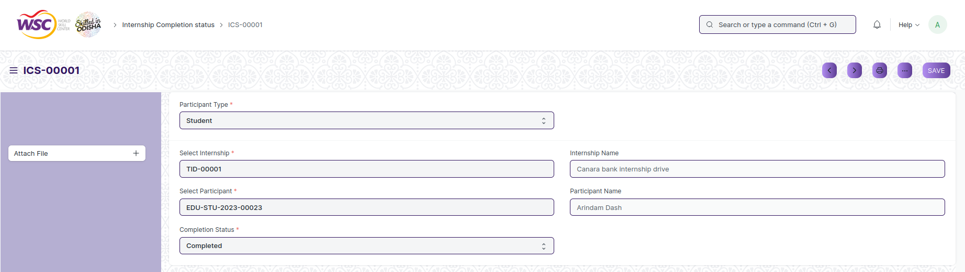

(View a saved record)

**Screen Type**

* Save

**Prerequisites**

* Record of the TnP Event for which the feedback is being given must be created first.

**Adding a new record**

As it is a save screen, follow the general procedure to create a save document as mentioned above .

After creating an event feedback , the record will be visible in the List view of the screen.

**Deleting a record**

As it a Save screen , follow the general procedure to delete a save document .

**Edit Record**

Follow the steps to view a saved internship application record.

Edit the field that you want to change.

Click on Save.

**Print Record**

As it is a Save screen , follow the general procedure to print a saved document.

**View Record in different format**

As it is a Save screen , follow the general procedure to view a saved document in different format.

# Placement

## Placement Drive

**Description**

The "Placement Drive" screen typically refers to a configuration or master data form where you define and manage records of different placement drives for the students of the organization, within the system.

The screen is accessible to Training and Placement Administrator and Students.

To access the Placement Drive screen ,go to :

***Home>Training and Placement>Placement>Placement Drive***

**Screen**

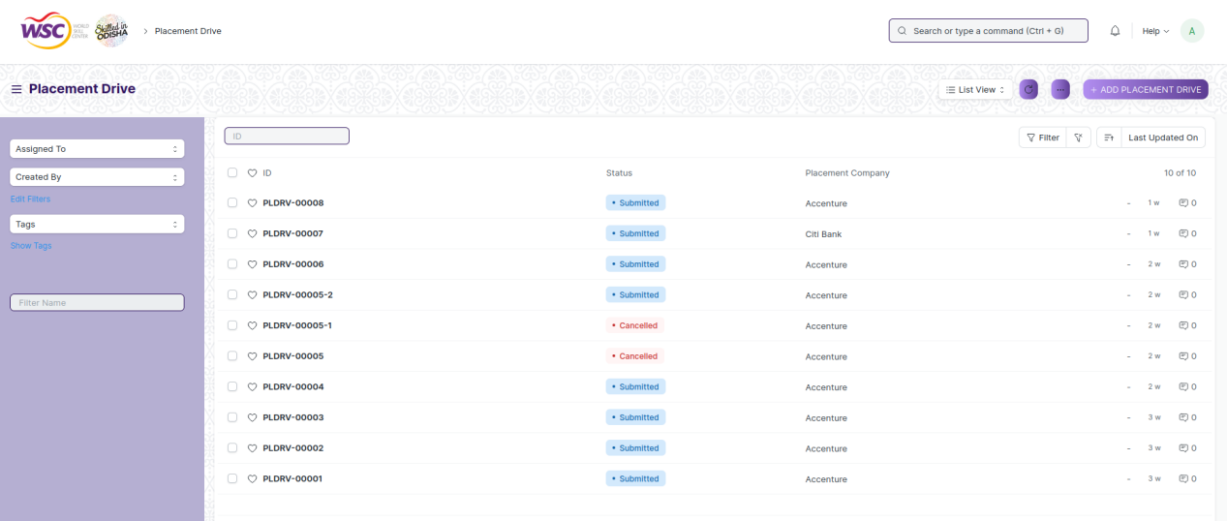

(List view of Placement Drive)

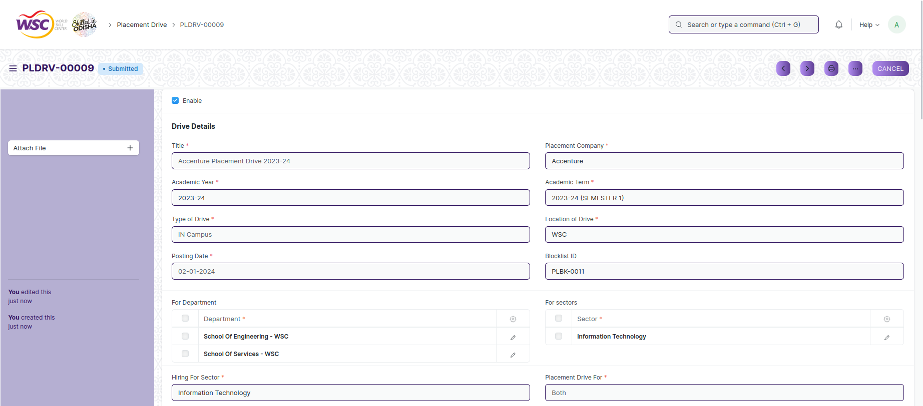

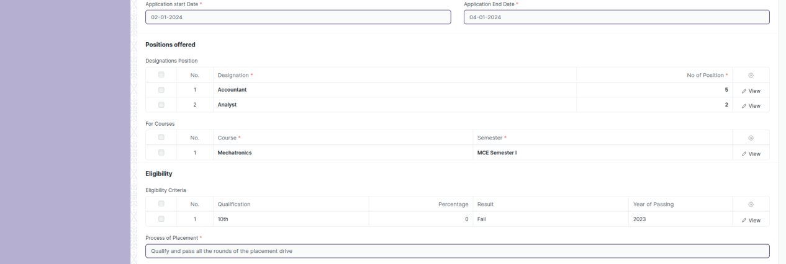

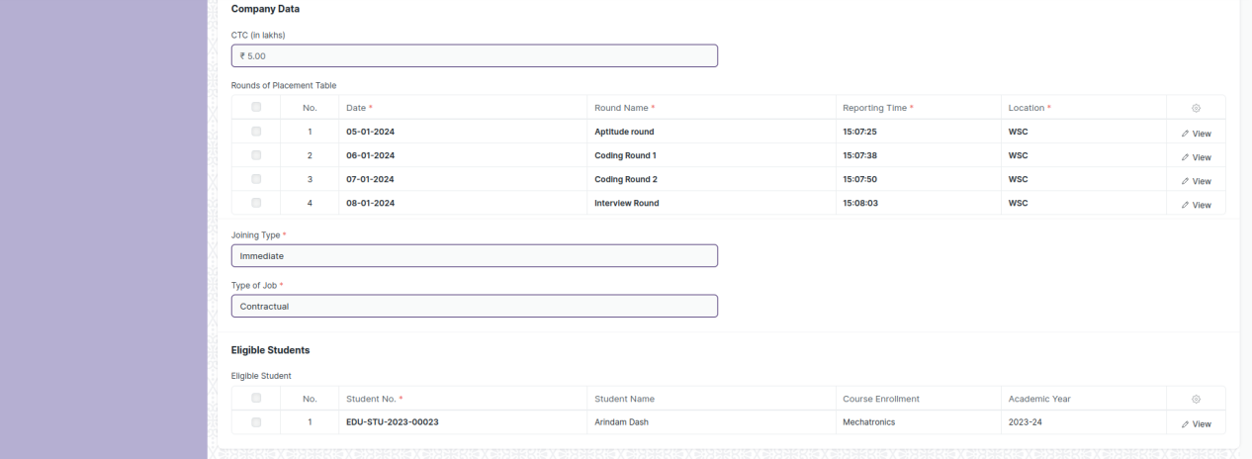

(View a saved record)

**Screen Type**

* Submit

**Prerequisites**

* Record of the placement company for which the placement drive is being created must be created first.

**Adding a new record**

As it is a submittable screen follow the general procedure to create a submittable document as mentioned above.

**Deleting a record**

If the document is not submitted , it is in draft state , you can delete the document by following the procedure to delete a save document.

If the document is submitted, follow the procedure to delete the submittable document.

**Amend record**

As it is a submittable screen , follow the general procedure to Amend the document.

**Edit record**

If the document is in draft state , the document can be editable.

Once the document is submitted , it cannot be edited.

**Print record**

Follow the general procedure to print a saved document.

**View record in different format**

Follow the general procedure to view a saved document in different format.

## Placement Drive Application

**Description**

The "Placement Drive Application" screen typically refers to a configuration or master data form where you define and manage records of applications submitted for a placement drive, within the system.

The screen is accessible to Training and Placement Administrator and Students.

To access the Placement Drive Application screen ,go to :

***Home>Training and Placement>Placement>Placement Drive Application***

**Screen**

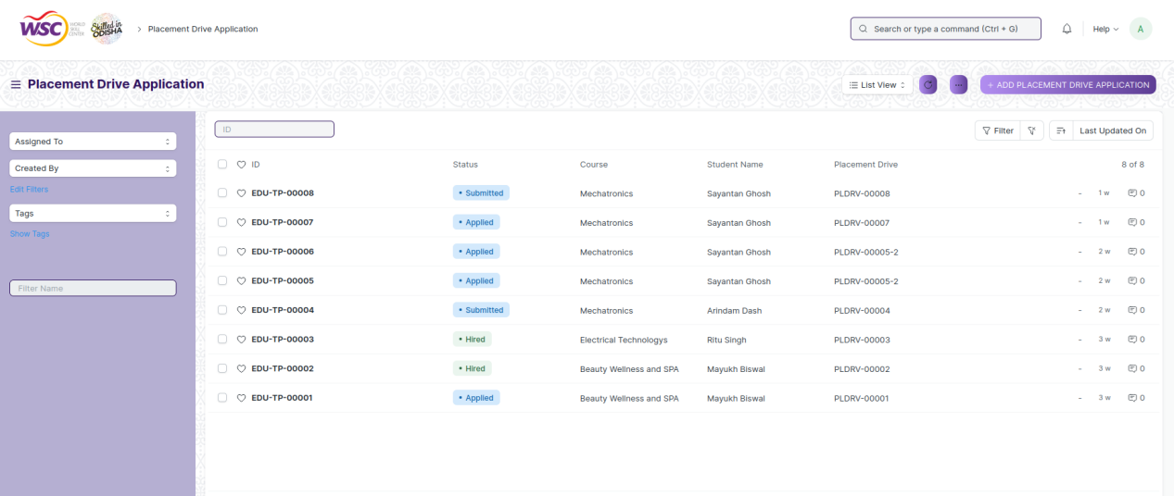

(List view of Placement Drive Application)

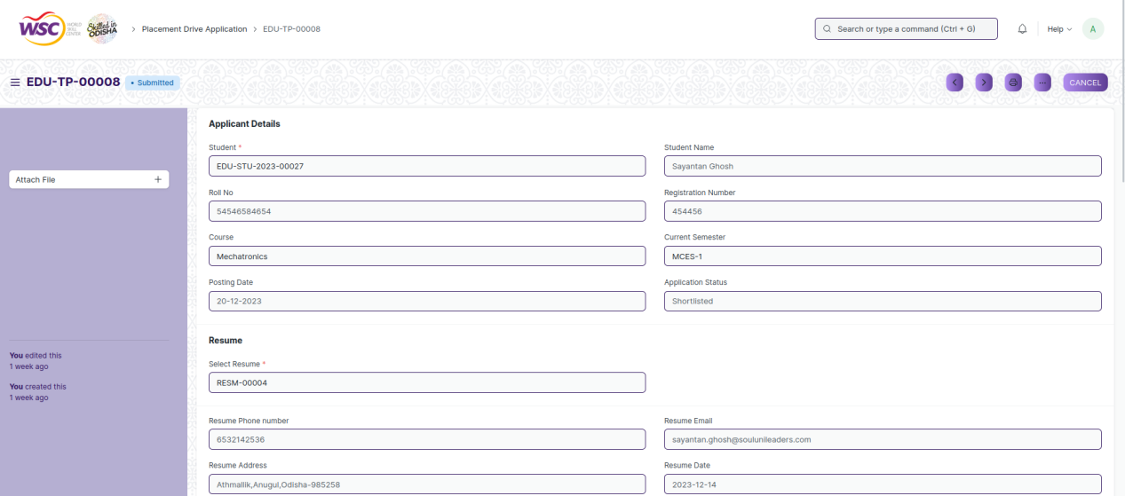

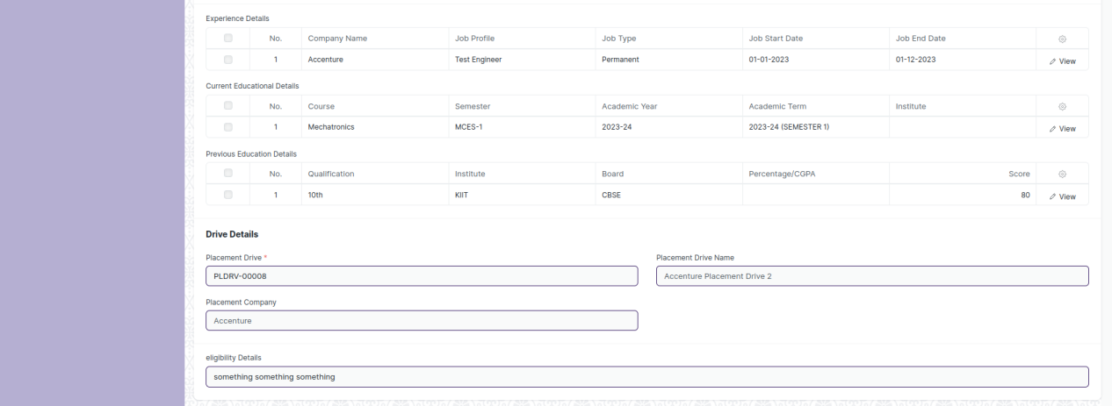

(View a saved record)

**Screen Type**

* Submit

**Prerequisites**

* Record of the placement company for which the placement drive is being created must be created first.

**Adding a new record**

As it is a submittable screen follow the general procedure to create a submittable document as mentioned above.

**Deleting a record**

If the document is not submitted , it is in draft state , you can delete the document by following the procedure to delete a save document.

If the document is submitted, follow the procedure to delete the submittable document.

**Amend record**

As it is a submittable screen , follow the general procedure to Amend the document.

**Edit record**

If the document is in draft state , the document can be editable.

Once the document is submitted , it cannot be edited.

**Print record**

Follow the general procedure to print a saved document.

**View record in different format**

Follow the general procedure to view a saved document in different format.

## Placement Blocked Student

**Description**

The "Placement Blocked Student" screen typically refers to a configuration or master data form where you define and manage records of students who have been blocked from one or more placement drives.

The screen is accessible to Training and Placement Administrator.

To access the Placement Blocked Student screen ,go to :

***Home>Training and Placement>Placement>Placement Blocked Student***

**Screen**

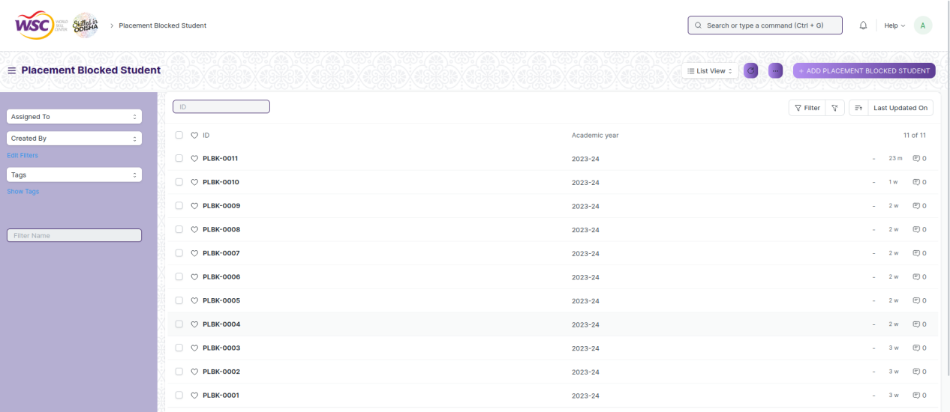

(List view of Placement Blocked Student)

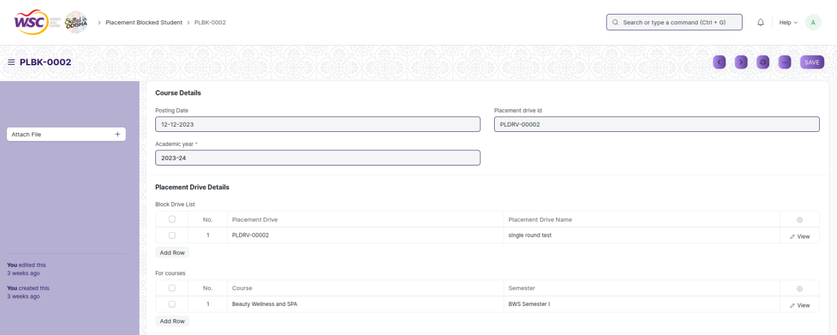



(View a saved record)

**Screen Type**

* Save

**Prerequisites**

* Record of the TnP Event for which the feedback is being given must be created first.

**Adding a new record**

As it is a save screen, follow the general procedure to create a save document as mentioned above .

After creating an event feedback , the record will be visible in the List view of the screen.

**Deleting a record**

As it a Save screen , follow the general procedure to delete a save document .

**Edit Record**

Follow the steps to view a saved internship application record.

Edit the field that you want to change.

Click on Save.

**Print Record**

As it is a Save screen , follow the general procedure to print a saved document.

**View Record in different format**

As it is a Save screen , follow the general procedure to view a saved document in different format.

## Placement Tool

**Description**

The "Placement Tool" screen typically refers to a configuration or master data form where you define and manage records of scheduling and result declaration of the rounds of a placement drive, within the system.

The screen is accessible to Training and Placement Administrator.

To access the Placement Tool screen ,go to :

***Home>Training and Placement>Placement>Placement Tool***

**Screen**

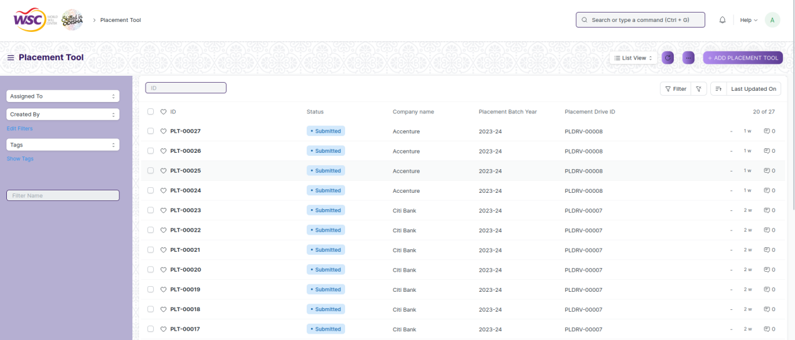

(List view of Placement Tool)

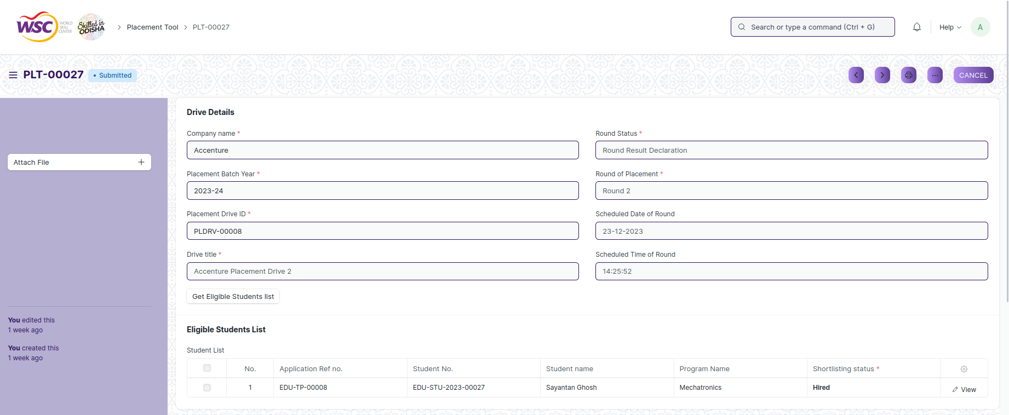

(View a saved record)

**Screen Type**

* Submit

**Prerequisites**

* Record of the placement company for which the placement drive is being created must be created first.

**Adding a new record**

As it is a submittable screen follow the general procedure to create a submittable document as mentioned above.

**Deleting a record**

If the document is not submitted , it is in draft state , you can delete the document by following the procedure to delete a save document.

If the document is submitted, follow the procedure to delete the submittable document.

**Amend record**

As it is a submittable screen , follow the general procedure to Amend the document.

**Edit record**

If the document is in draft state , the document can be editable.

Once the document is submitted , it cannot be edited.

**Print record**

Follow the general procedure to print a saved document.

**View record in different format**

Follow the general procedure to view a saved document in different format.

## Selection Round

**Description**

The "Selection Round" screen typically refers to a configuration or master data form where you define and manage records of the students who have been selected for a placement round in a placement drive, within the system.

The screen is accessible to Training and Placement Administrator and Students.

To access the Selection Round screen ,go to :

***Home>Training and Placement>Placement>Selection Round***

**Screen**

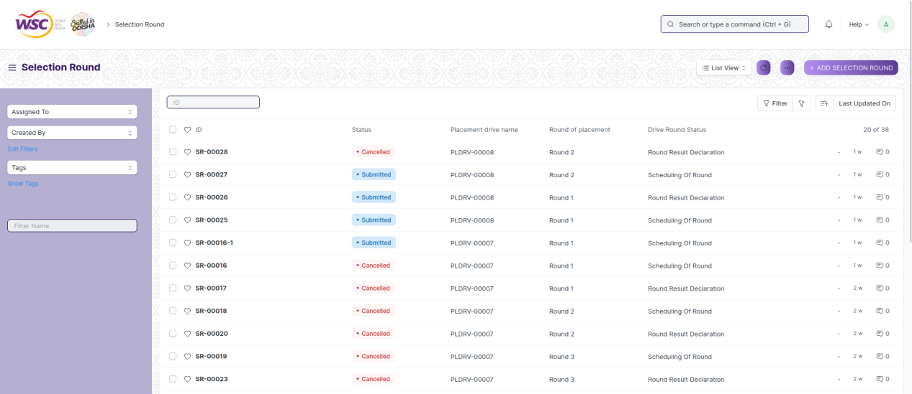

(List view of Selection Round)

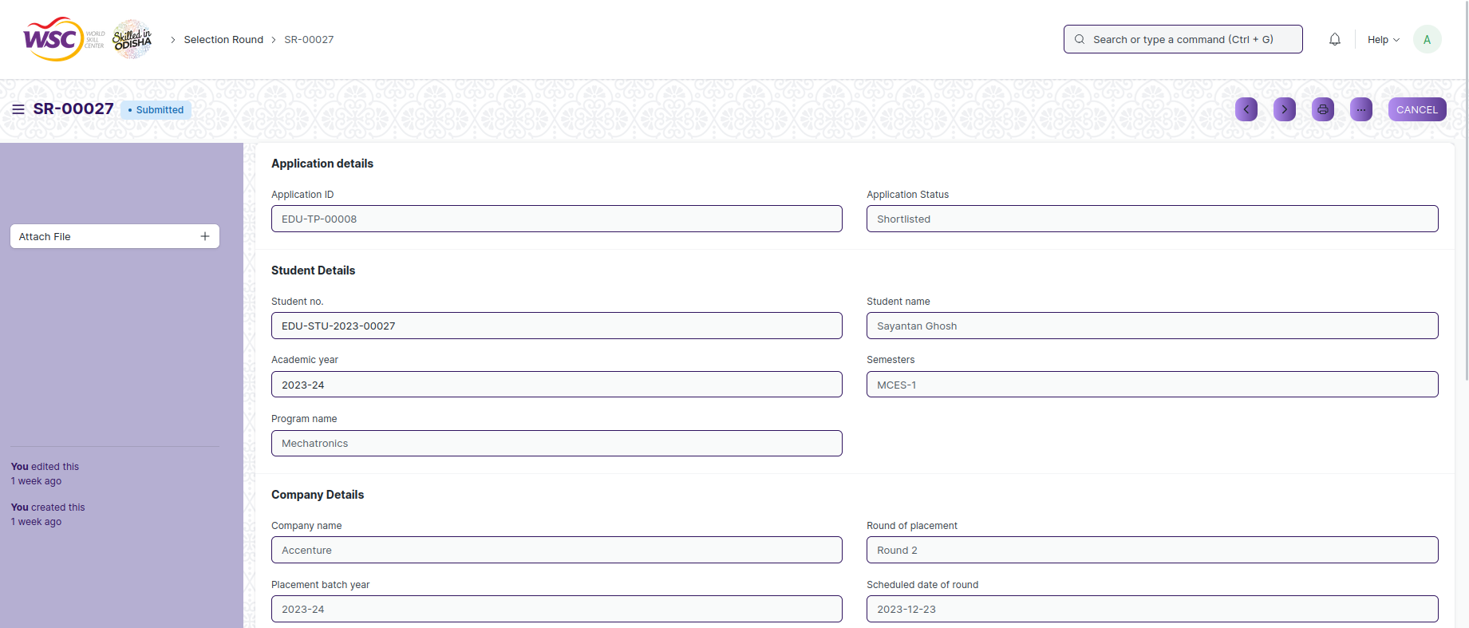



(View a saved record)

**Screen Type**

* Submit

**Prerequisites**

* Not Available

**Adding a new record**

As it is a submittable screen follow the general procedure to create a submittable document as mentioned above.

**Deleting a record**

If the document is not submitted , it is in draft state , you can delete the document by following the procedure to delete a save document.

If the document is submitted, follow the procedure to delete the submittable document.

**Amend record**

As it is a submittable screen , follow the general procedure to Amend the document.

**Edit record**

If the document is in draft state , the document can be editable.

Once the document is submitted , it cannot be edited.

**Print record**

Follow the general procedure to print a saved document.

**View record in different format**

follow the general procedure to view a saved document in different format.

# Reports

## Selection Round Report

**Description**

The “Selection Round Report” screen typically refers to a report screen where a student can see the details of their performance across different placement rounds.

The screen is accessible to Training and Placement Administrator and Students.

To access the Selection Round screen ,go to :

***Home>Training and Placement>Placement>Reports>Selection Round Report***

**Screen**

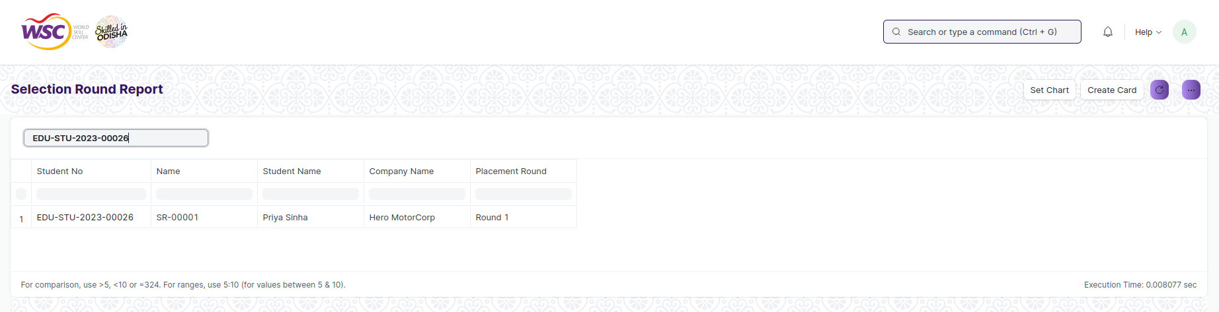

(view of selection round report screen)

**Screen Type**

* Report

**Prerequisites**

* Not Available

**Searching for a students report**

Select the students ID from the drop down list in the field.

# Security: User access and authorization

The screens and the data in them is made secure by creating roles with different permissions and then assigning those roles the appropriate users. For this screen following are the roles and their corresponding permissions:

### 

## Placement Company

|  |  |  |  |  |  |  |  |  |
| --- | --- | --- | --- | --- | --- | --- | --- | --- |
| **ID** | **Role** | **Read** | **Write** | **Create** | **Delete** | **Submit** | **Cancel** | **Amend** |
| 1 | Training and Placement Administrator | Yes | Yes | Yes | NA | NA | NA | NA |
| 2 | Student | Yes | No | No | NA | NA | NA | NA |

## Entrepreneurship

|  |  |  |  |  |  |  |  |  |
| --- | --- | --- | --- | --- | --- | --- | --- | --- |
| **ID** | **Role** | **Read** | **Write** | **Create** | **Delete** | **Submit** | **Cancel** | **Amend** |
| 1 | Training and Placement Administrator | Yes | Yes | Yes | NA | NA | NA | NA |

## Sector

|  |  |  |  |  |  |  |  |  |
| --- | --- | --- | --- | --- | --- | --- | --- | --- |
| **ID** | **Role** | **Read** | **Write** | **Create** | **Delete** | **Submit** | **Cancel** | **Amend** |
| 1 | Training and Placement Administrator | Yes | Yes | Yes | NA | NA | NA | NA |

## Resume

|  |  |  |  |  |  |  |  |  |
| --- | --- | --- | --- | --- | --- | --- | --- | --- |
| **ID** | **Role** | **Read** | **Write** | **Create** | **Delete** | **Submit** | **Cancel** | **Amend** |
| 1 | Training and Placement Administrator | Yes | Yes | Yes | NA | NA | NA | NA |
| 2 | Student | Yes | Yes | Yes | NA | NA | NA | NA |

## TnP Program

|  |  |  |  |  |  |  |  |  |
| --- | --- | --- | --- | --- | --- | --- | --- | --- |
| **ID** | **Role** | **Read** | **Write** | **Create** | **Delete** | **Submit** | **Cancel** | **Amend** |
| 1 | Training and Placement Administrator | Yes | Yes | Yes | NA | NA | NA | NA |
| 2 | Student | Yes | No | No | NA | NA | NA | NA |
| 3 | Employee | Yes | No | No | NA | NA | NA | NA |

## TnP Event

|  |  |  |  |  |  |  |  |  |
| --- | --- | --- | --- | --- | --- | --- | --- | --- |
| **ID** | **Role** | **Read** | **Write** | **Create** | **Delete** | **Submit** | **Cancel** | **Amend** |
| 1 | Training and Placement Administrator | Yes | Yes | Yes | NA | Yes | Yes | Yes |
| 2 | Student | Yes | No | No | NA | NA | NA | NA |
| 3 | Employee | Yes | No | No | NA | NA | NA | NA |

## Participant Registration

|  |  |  |  |  |  |  |  |  |
| --- | --- | --- | --- | --- | --- | --- | --- | --- |
| **ID** | **Role** | **Read** | **Write** | **Create** | **Delete** | **Submit** | **Cancel** | **Amend** |
| 1 | Training and Placement Administrator | Yes | Yes | Yes | NA | Yes | Yes | Yes |
| 2 | Student | Yes | Yes | Yes | NA | Yes | Yes | Yes |
| 3 | Employee | Yes | Yes | Yes | NA | Yes | Yes | Yes |

## Participant Attendance

|  |  |  |  |  |  |  |  |  |
| --- | --- | --- | --- | --- | --- | --- | --- | --- |
| **ID** | **Role** | **Read** | **Write** | **Create** | **Delete** | **Submit** | **Cancel** | **Amend** |
| 1 | Training and Placement Administrator | Yes | Yes | Yes | NA | Yes | Yes | Yes |
| 2 | Student | Yes | No | No | NA | NA | NA | NA |
| 3 | Employee | Yes | No | No | NA | NA | NA | NA |

## Event Feedback

|  |  |  |  |  |  |  |  |  |
| --- | --- | --- | --- | --- | --- | --- | --- | --- |
| **ID** | **Role** | **Read** | **Write** | **Create** | **Delete** | **Submit** | **Cancel** | **Amend** |
| 1 | Training and Placement Administrator | Yes | Yes | Yes | NA | NA | NA | NA |
| 2 | Student | Yes | Yes | Yes | NA | NA | NA | NA |
| 3 | Employee | Yes | Yes | Yes | NA | NA | NA | NA |

## Generate Certificate Tool

|  |  |  |  |  |  |  |  |  |
| --- | --- | --- | --- | --- | --- | --- | --- | --- |
| **ID** | **Role** | **Read** | **Write** | **Create** | **Delete** | **Submit** | **Cancel** | **Amend** |
| 1 | Training and Placement Administrator | Yes | Yes | Yes | NA | Yes | Yes | Yes |

## Generate Certificate

|  |  |  |  |  |  |  |  |  |
| --- | --- | --- | --- | --- | --- | --- | --- | --- |
| **ID** | **Role** | **Read** | **Write** | **Create** | **Delete** | **Submit** | **Cancel** | **Amend** |
| 1 | Training and Placement Administrator | Yes | Yes | Yes | NA | Yes | Yes | Yes |

## Internship Drive

|  |  |  |  |  |  |  |  |  |
| --- | --- | --- | --- | --- | --- | --- | --- | --- |
| **ID** | **Role** | **Read** | **Write** | **Create** | **Delete** | **Submit** | **Cancel** | **Amend** |
| 1 | Training and Placement Administrator | Yes | Yes | Yes | NA | NA | NA | NA |
| 2 | Student | Yes | No | No | NA | NA | NA | NA |
| 3 | Employee | Yes | No | No | NA | NA | NA | NA |

## Internship Application

|  |  |  |  |  |  |  |  |  |
| --- | --- | --- | --- | --- | --- | --- | --- | --- |
| **ID** | **Role** | **Read** | **Write** | **Create** | **Delete** | **Submit** | **Cancel** | **Amend** |
| 1 | Training and Placement Administrator | Yes | Yes | Yes | NA | Yes | Yes | Yes |
| 2 | Student | Yes | Yes | Yes | NA | Yes | Yes | Yes |
| 3 | Employee | Yes | Yes | Yes | NA | Yes | Yes | Yes |

## Internship Participant Selection

|  |  |  |  |  |  |  |  |  |
| --- | --- | --- | --- | --- | --- | --- | --- | --- |
| **ID** | **Role** | **Read** | **Write** | **Create** | **Delete** | **Submit** | **Cancel** | **Amend** |
| 1 | Training and Placement Administrator | Yes | Yes | Yes | NA | Yes | Yes | Yes |

## Internship Final List Declaration

|  |  |  |  |  |  |  |  |  |
| --- | --- | --- | --- | --- | --- | --- | --- | --- |
| **ID** | **Role** | **Read** | **Write** | **Create** | **Delete** | **Submit** | **Cancel** | **Amend** |
| 1 | Training and Placement Administrator | Yes | Yes | Yes | NA | Yes | Yes | Yes |
| 2 | Student | Yes | No | No | NA | NA | NA | NA |
| 3 | Employee | Yes | No | No | NA | NA | NA | NA |

## Internship Completion Status

|  |  |  |  |  |  |  |  |  |
| --- | --- | --- | --- | --- | --- | --- | --- | --- |
| **ID** | **Role** | **Read** | **Write** | **Create** | **Delete** | **Submit** | **Cancel** | **Amend** |
| 1 | Training and Placement Administrator | Yes | Yes | Yes | NA | NA | NA | NA |

## Placement Drive

|  |  |  |  |  |  |  |  |  |
| --- | --- | --- | --- | --- | --- | --- | --- | --- |
| **ID** | **Role** | **Read** | **Write** | **Create** | **Delete** | **Submit** | **Cancel** | **Amend** |
| 1 | Training and Placement Administrator | Yes | Yes | Yes | NA | Yes | Yes | Yes |
| 2 | Student | Yes | No | No | NA | NA | NA | NA |

## Placement Drive Application

|  |  |  |  |  |  |  |  |  |
| --- | --- | --- | --- | --- | --- | --- | --- | --- |
| **ID** | **Role** | **Read** | **Write** | **Create** | **Delete** | **Submit** | **Cancel** | **Amend** |
| 1 | Training and Placement Administrator | Yes | Yes | Yes | NA | Yes | Yes | Yes |
| 2 | Student | Yes | Yes | Yes | NA | Yes | Yes | Yes |

## Placement Blocked Student

|  |  |  |  |  |  |  |  |  |
| --- | --- | --- | --- | --- | --- | --- | --- | --- |
| **ID** | **Role** | **Read** | **Write** | **Create** | **Delete** | **Submit** | **Cancel** | **Amend** |
| 1 | Training and Placement Administrator | Yes | Yes | Yes | NA | NA | NA | NA |

## Placement Tool

|  |  |  |  |  |  |  |  |  |
| --- | --- | --- | --- | --- | --- | --- | --- | --- |
| **ID** | **Role** | **Read** | **Write** | **Create** | **Delete** | **Submit** | **Cancel** | **Amend** |
| 1 | Training and Placement Administrator | Yes | Yes | Yes | NA | Yes | Yes | Yes |

## Selection Round

|  |  |  |  |  |  |  |  |  |
| --- | --- | --- | --- | --- | --- | --- | --- | --- |
| **ID** | **Role** | **Read** | **Write** | **Create** | **Delete** | **Submit** | **Cancel** | **Amend** |
| 1 | Training and Placement Administrator | Yes | Yes | Yes | NA | Yes | Yes | Yes |
| 2 | Student | Yes | No | No | NA | No | No | No |

## Selection Round Report

|  |  |  |  |  |  |  |  |  |
| --- | --- | --- | --- | --- | --- | --- | --- | --- |
| **ID** | **Role** | **Read** | **Write** | **Create** | **Delete** | **Submit** | **Cancel** | **Amend** |
| 1 | Training and Placement Administrator | Yes | NA | NA | NA | NA | NA | NA |
| 2 | Student | Yes | NA | NA | NA | NA | No | NA |